**WEEK 1:**

**WRITEUP:**

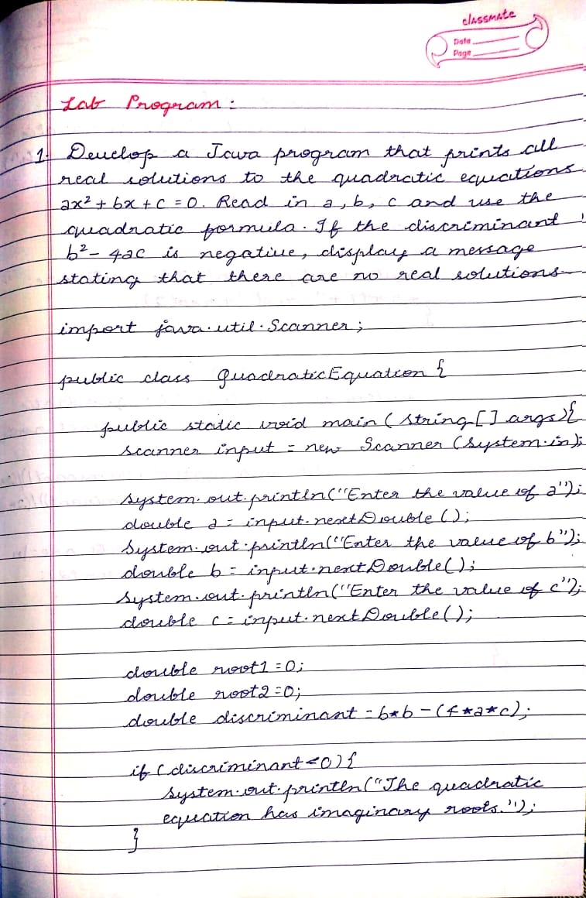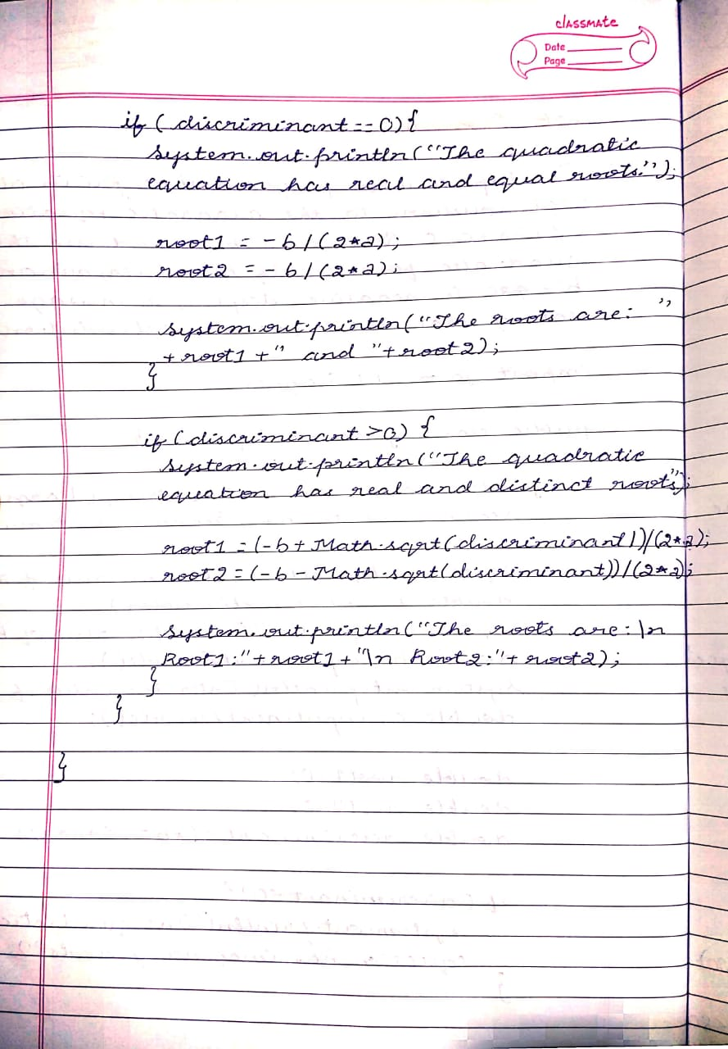

**SOURCE CODE:**

**import java.util.Scanner;**

**public class QuadraticEquation {**

**public static void main(String[] args){**

**Scanner input= new Scanner(System.in);**

**System.out.println("Enter the value of a");**

**double a=input.nextDouble();**

**System.out.println("Enter the value of b");**

**double b=input.nextDouble();**

**System.out.println("Enter the value of c");**

**double c=input.nextDouble();**

**double root1=0;**

**double root2=0;**

**double discriminant= b*b-(4*a*c);**

**if(discriminant<0){**

**System.out.println("The quadratic equation has imaginary roots.");**

**}**

**if(discriminant==0){**

**System.out.println("The quadratic equation has real and equal roots.");**

**root1=-b/(2*a);**

**root2=-b/(2*a);**

**System.out.println("The roots are: "+root1+" and "+root2);**

**}**

**if(discriminant>0){**

**System.out.println("The quadratic equation has real and distinct roots.");**

**root1=(-b+Math.sqrt(discriminant))/(2*a);**

**root2=(-b-Math.sqrt(discriminant))/(2*a);**

**System.out.println("The roots are:\n Root1:"+root1+"\n Root2:"+root2);**

**}**

**}**

**}**

**OUTPUT:**

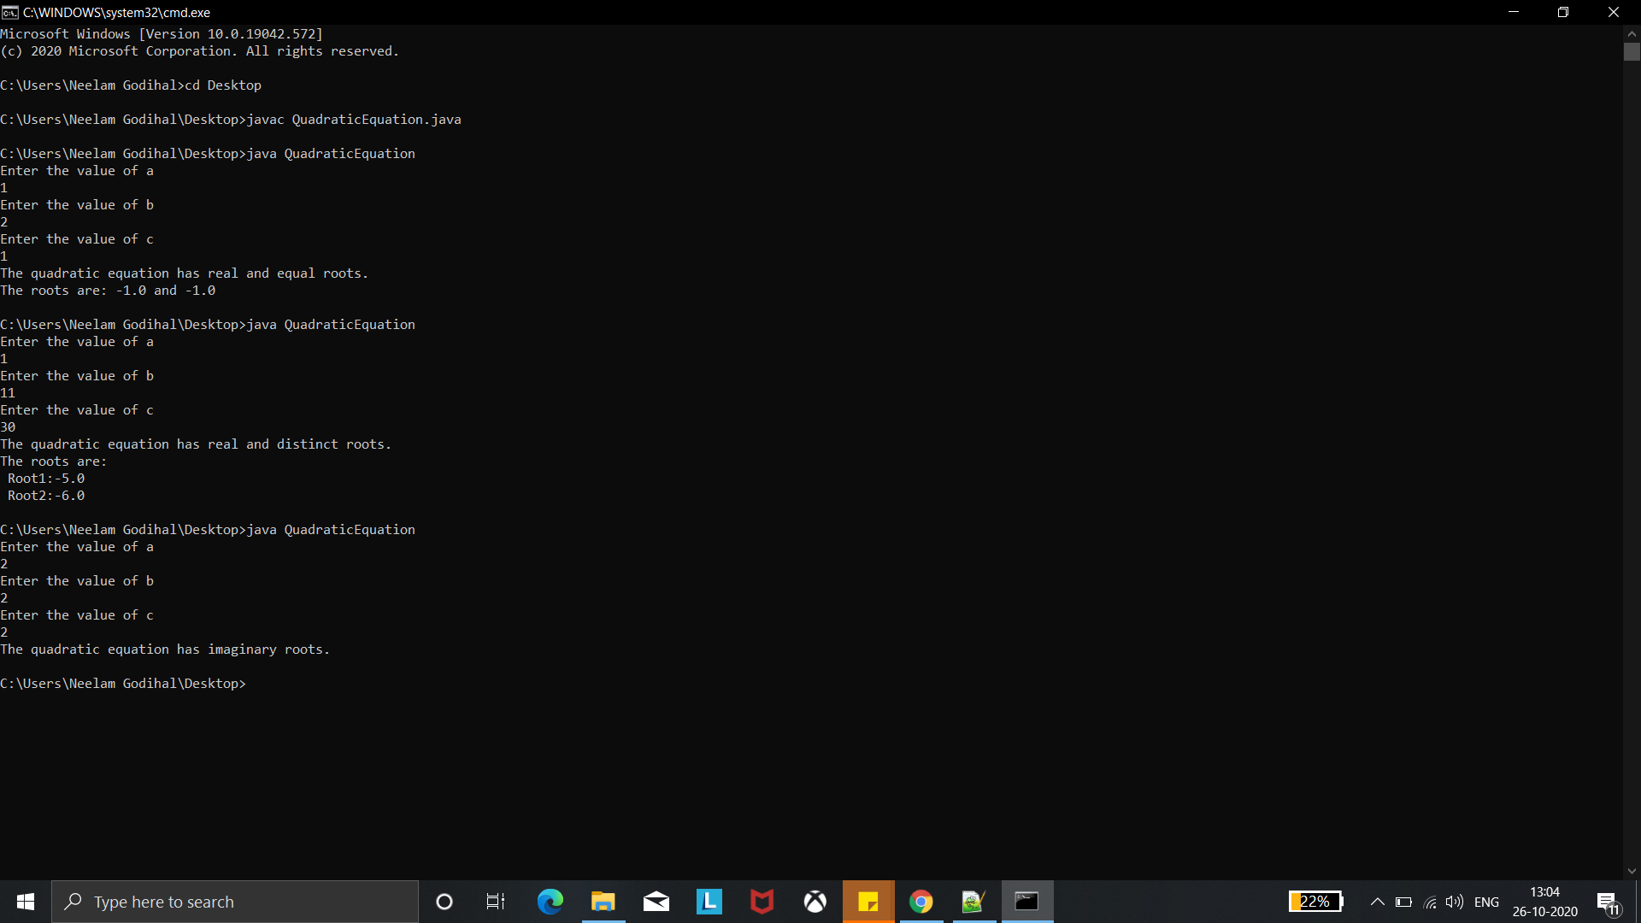

**WEEK 2:**

**WRITEUP:**

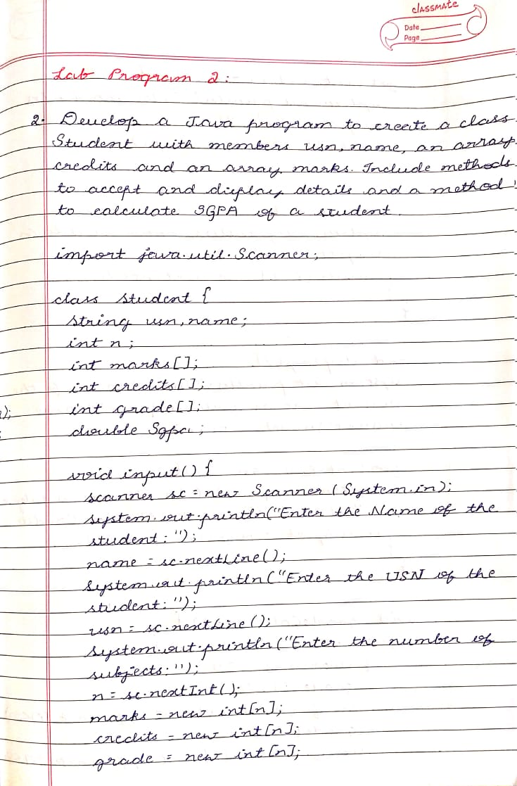

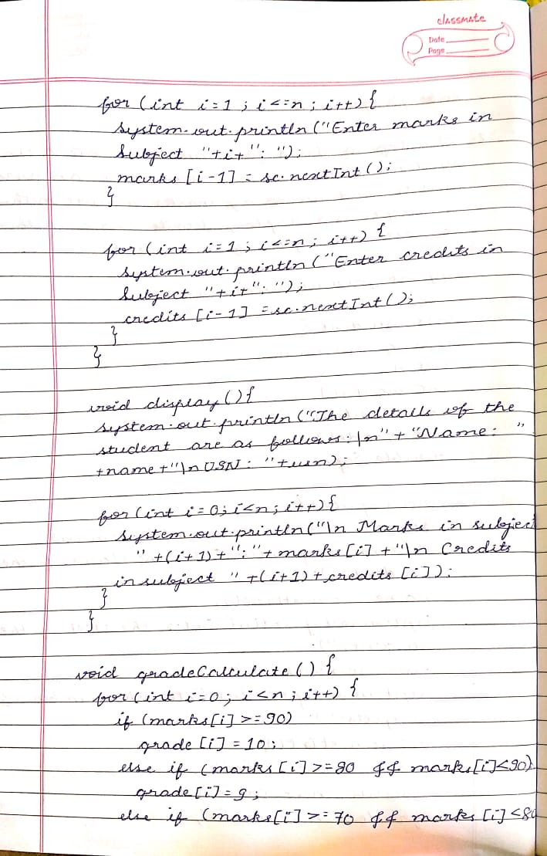

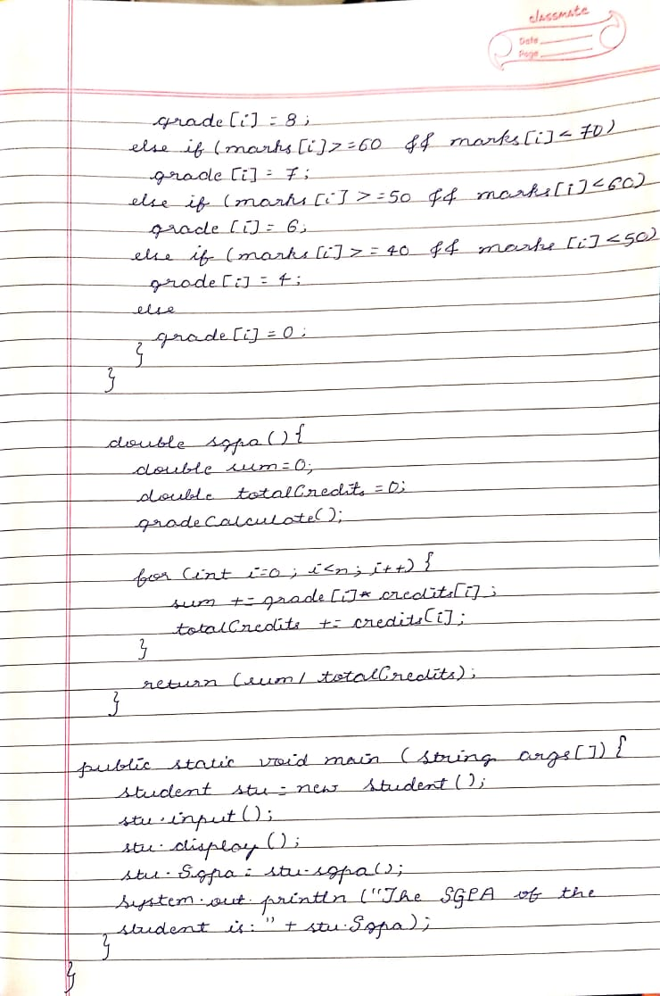

**SOURCE CODE:**

**class Student {**

**String usn,name;**

**int n;**

**int marks[];**

**int credits[];**

**int grade[];**

**double Sgpa;**

**void input() {**

**Scanner sc = new Scanner(System.in);**

**System.out.println("Enter the Name of the student:");**

**name = sc.nextLine();**

**System.out.println("Enter the USN of the student:");**

**usn = sc.nextLine();**

**System.out.println("Enter the number of subjects:");**

**n = sc.nextInt();**

**marks = new int[n];**

**credits = new int[n];**

**grade = new int[n];**

**for(int i=1;i<=n;i++){**

**System.out.println("Enter marks in Subject "+i+": ");**

**marks[i-1]=sc.nextInt();**

**}**

**for(int i=1;i<=n;i++){**

**System.out.println("Enter credits in Subject "+i+": ");**

**credits[i-1]=sc.nextInt();**

**}**

**}**

**void display(){**

**System.out.println("The details of the student are as folloows:\n"+"Name: "+name+"\nUSN: "+usn);**

**for(int i=0;i<n;i++){**

**System.out.println("\n Marks in subject "+(i+1)+":"+marks[i]+"\n Credits in subject "+(i+1)+credits[i]);**

**}**

**}**

**void gradeCalculate() {**

**for(int i=0;i<n;i++){**

**if(marks[i]>= 90)**

**grade[i]=10;**

**else if (marks[i]>=80 && marks[i]<90)**

**grade[i]=9;**

**else if (marks[i]>=70 && marks[i]<80)**

**grade[i]=8;**

**else if (marks[i]>=60 && marks[i]<70)**

**grade[i]=7;**

**else if (marks[i]>=50 && marks[i]<60)**

**grade[i]=6;**

**else if (marks[i]>=40 && marks[i]<50)**

**grade[i]=4;**

**else**

**grade[i]=0;**

**}**

**}**

**double sgpa(){**

**double sum=0;**

**double totalCredits=0;**

**gradeCalculate();**

**for(int i=0;i<n;i++){**

**sum += grade[i]*credits[i];**

**totalCredits += credits[i];**

**}**

**return (sum/totalCredits);**

**}**

**public static void main(String args[]){**

**Student stu = new Student();**

**stu.input();**

**stu.display();**

**stu.Sgpa=stu.sgpa();**

**System.out.println("The SGPA of the student is:"+stu.Sgpa);**

**}**

**}**

**OUTPUT:**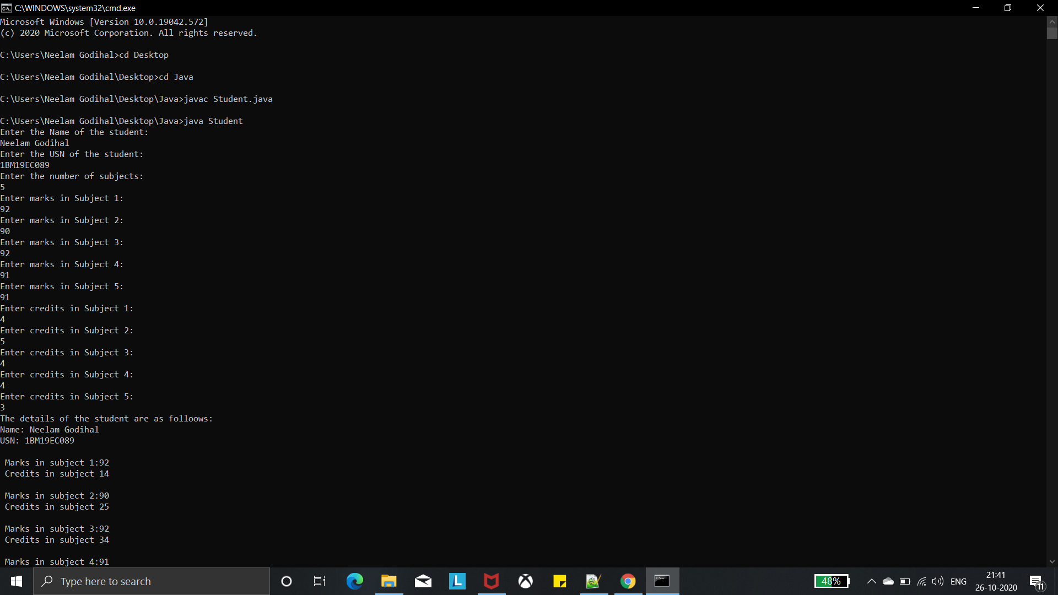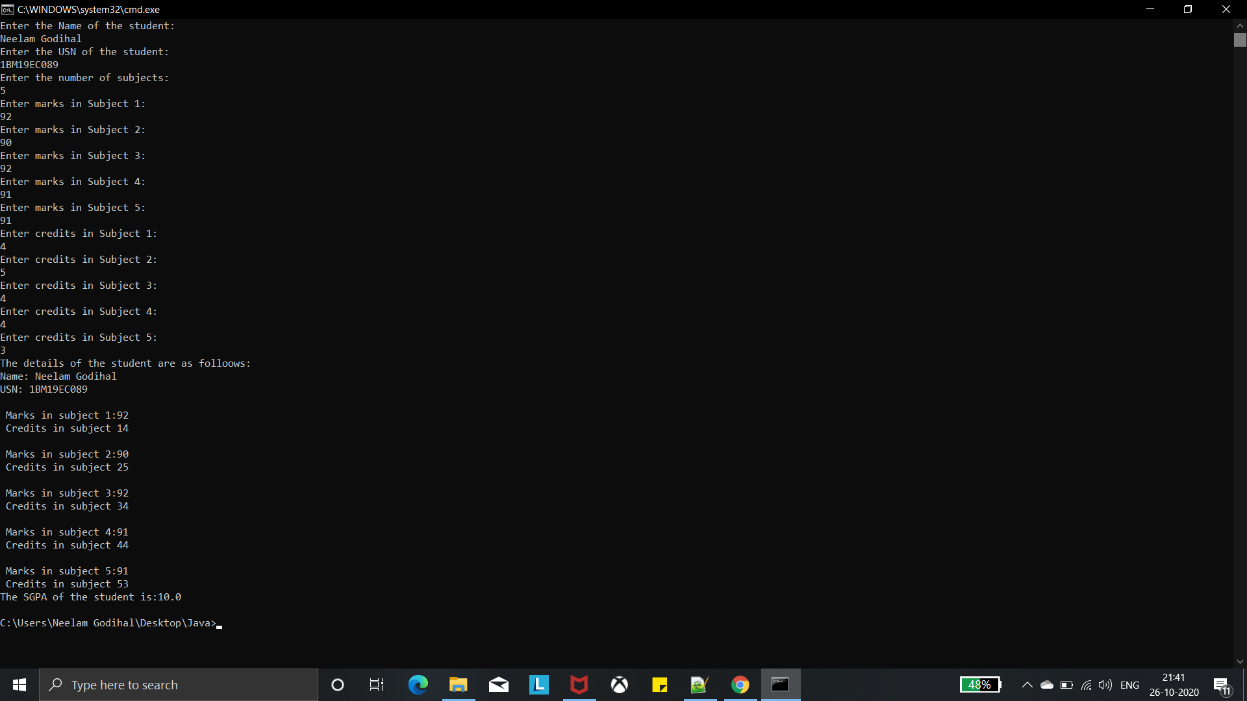

**WEEK 3:**

**WRITEUP:**

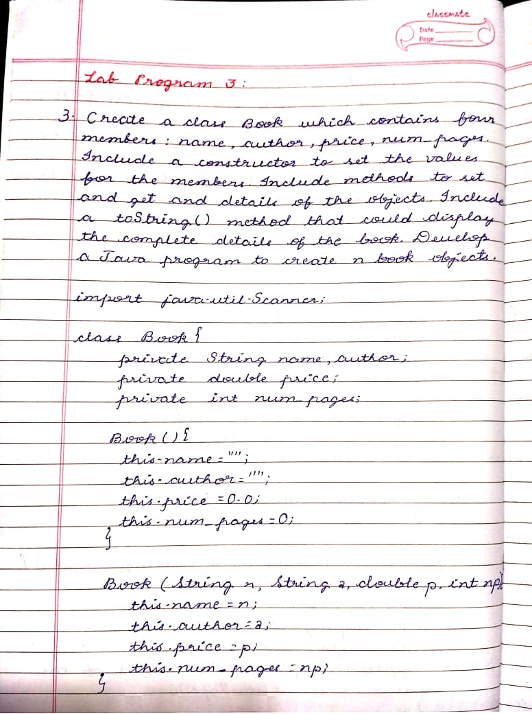

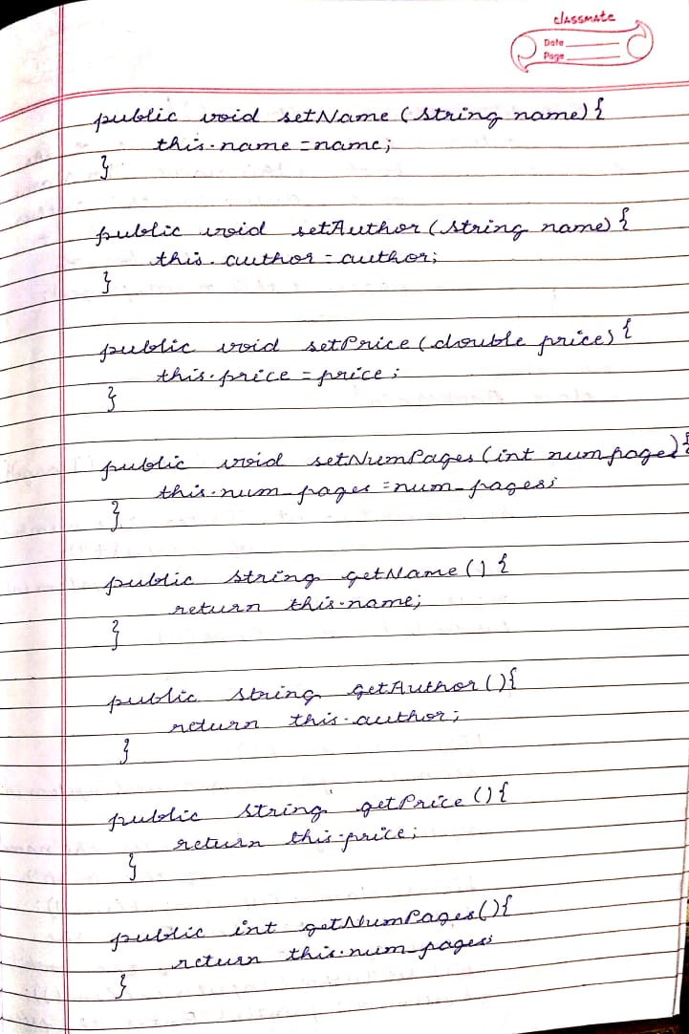

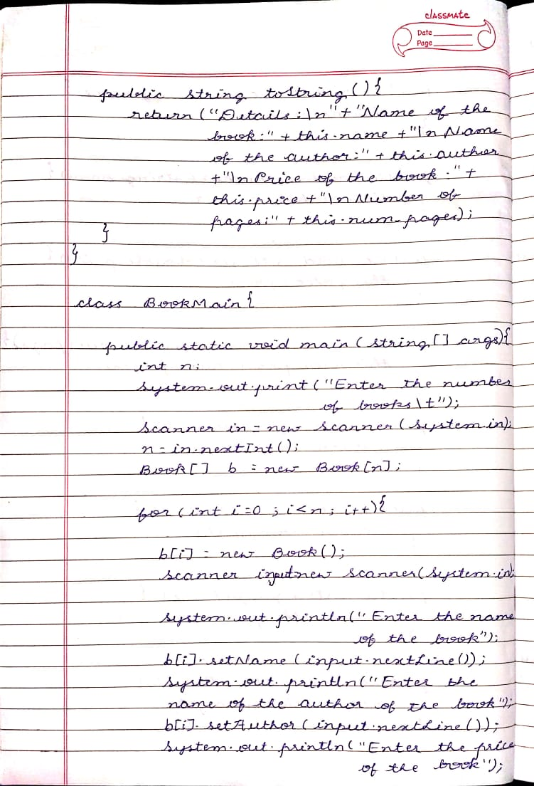

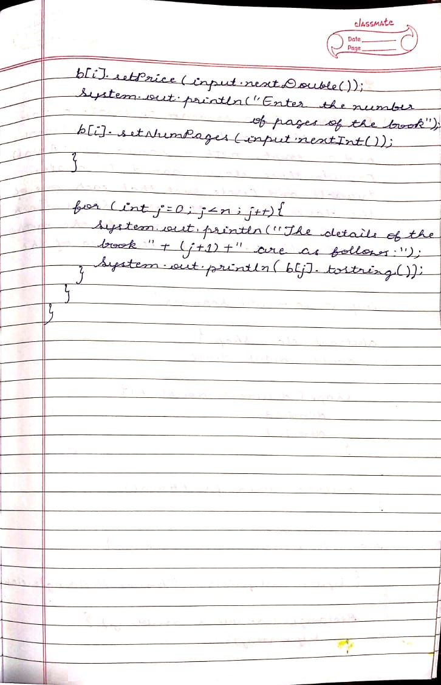

**SOURCE CODE:**

**import java.util.Scanner;**

**class Book{**

**private String name,author;**

**private double price;**

**private int num_pages;**

**Book(){**

**this.name="";**

**this.author="";**

**this.price=0.0;**

**this.num_pages=0;**

**}**

**Book(String n,String a,double p,int np){**

**this.name=n;**

**this.author=a;**

**this.price=p;**

**this.num_pages=np;**

**}**

**public void setName(String name){**

**this.name=name;**

**}**

**public void setAuthor(String author){**

**this.author=author;**

**}**

**public void setPrice(double price){**

**this.price=price;**

**}**

**public void setNumPages(int num_pages){**

**this.num_pages=num_pages;**

**}**

**public String getName(){**

**return this.name;**

**}**

**public String getAuthor(){**

**return this.author;**

**}**

**public double getPrice(){**

**return this.price;**

**}**

**public int getNumPages(){**

**return this.num_pages;**

**}**

**public String toString(){**

**return("Details:\n"+"Name of the book:"+this.name+"\nName of the author:"+this.author+"\nPrice of the book:"+this.price+"\nNumber of pages:"+this.num_pages);**

**}**

**}**

**class Main{**

**public static void main(String[] args){**

**int n;**

**System.out.print("Enter the number of books\t");**

**Scanner in = new Scanner(System.in);**

**n = in.nextInt();**

**Book[] b=new Book[n];**

**for(int i=0;i<n;i++){**

**b[i] = new Book();**

**Scanner input = new Scanner(System.in);**

**System.out.println("Enter the name of the book");**

**b[i].setName(input.nextLine());**

**System.out.println("Enter the name of the author of the book");**

**b[i].setAuthor(input.nextLine());**

**System.out.println("Enter the price of the book");**

**b[i].setPrice(input.nextDouble());**

**System.out.println("Enter the number of pages of the book");**

**b[i].setNumPages(input.nextInt());**

**}**

**for(int j=0;j<n;j++){**

**System.out.println("The details of book "+(j+1)+" are as follows:");**

**System.out.println(b[j].toString());**

**}**

**}**

**}**

**OUTPUT:**

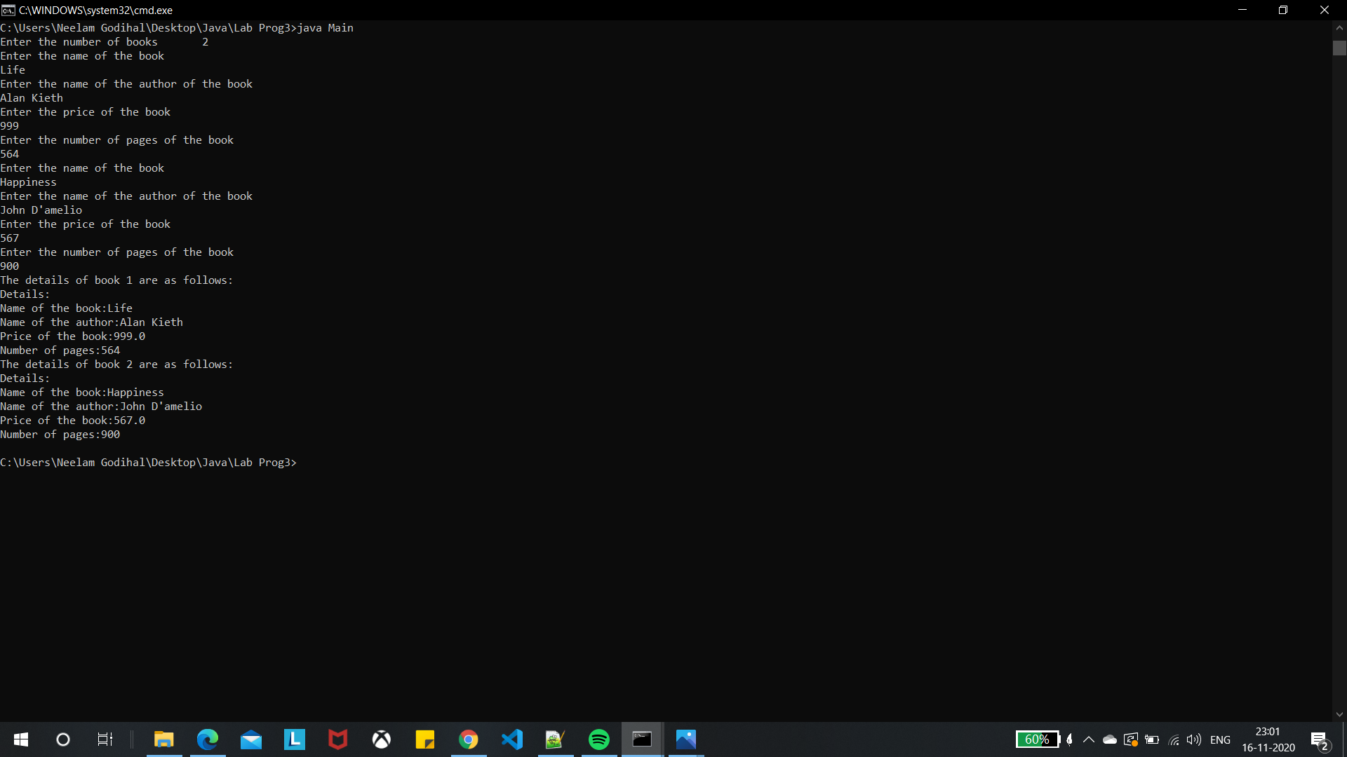

**WEEK 4:**

**WRITEUP:**

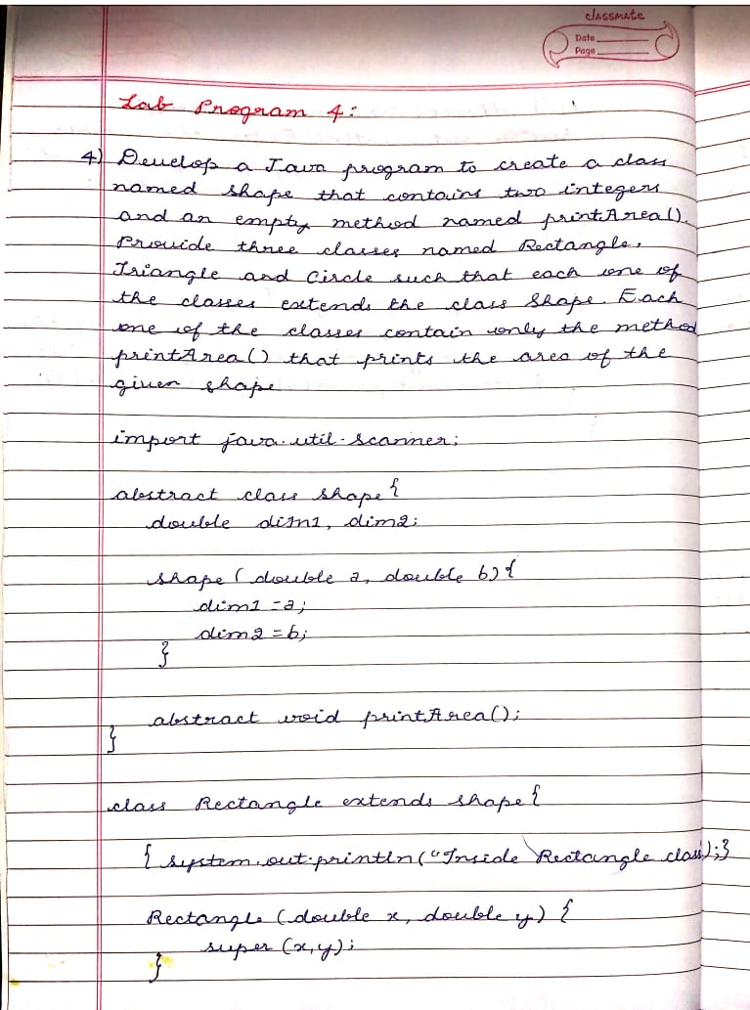

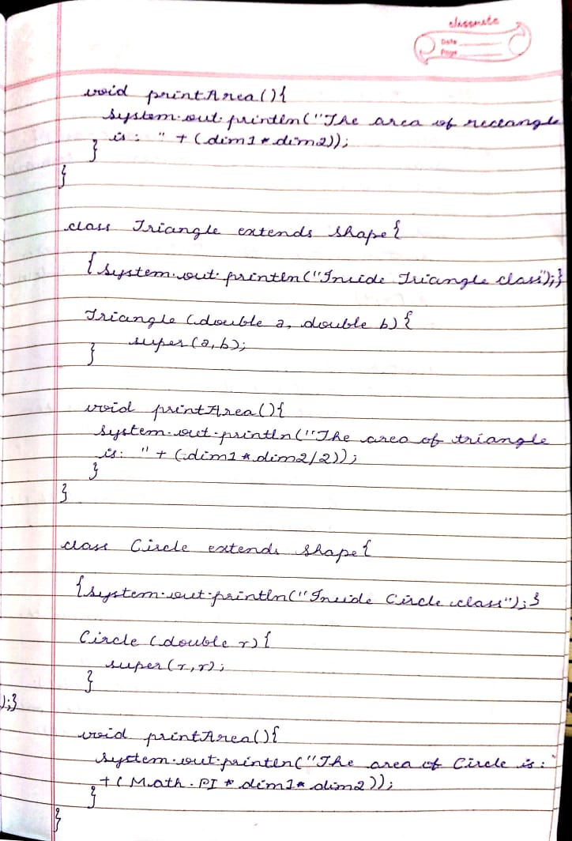

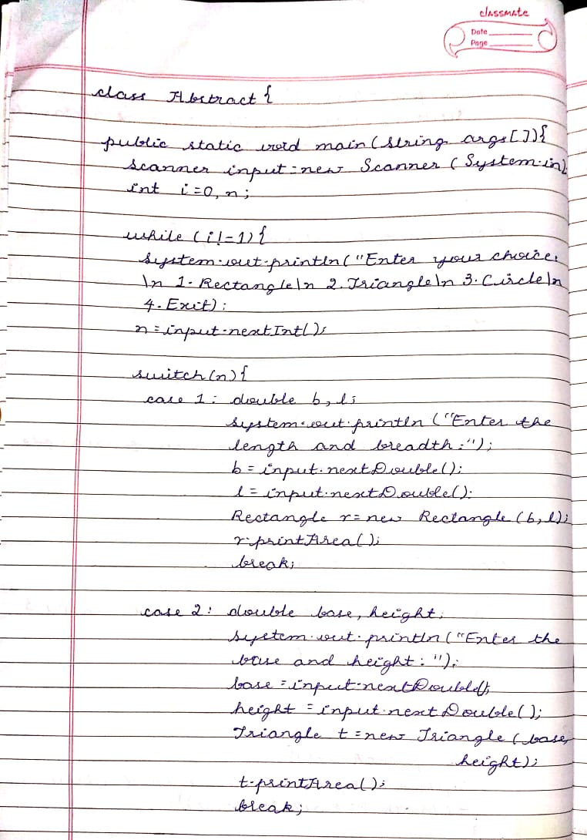

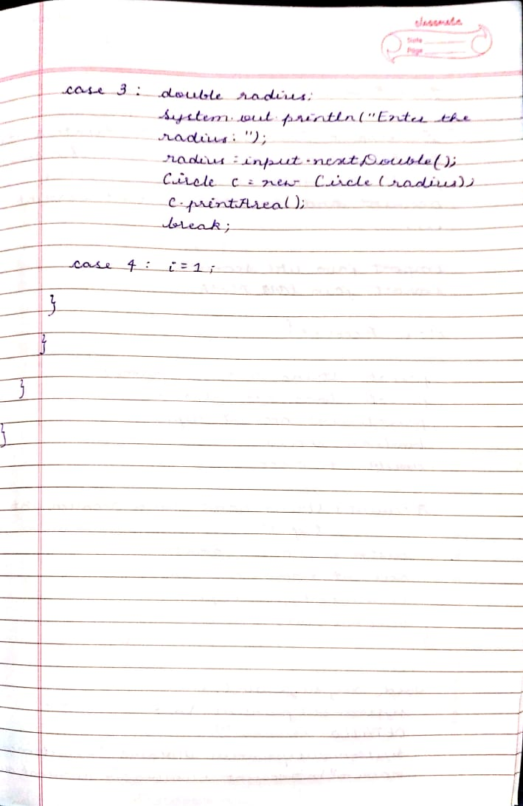

**SOURCE CODE:**

**import java.util.Scanner;**

**abstract class Shape{**

**double dim1,dim2;**

**Shape(double a,double b){**

**dim1=a;**

**dim2=b;**

**}**

**abstract void printArea();**

**}**

**class Rectangle extends Shape{**

**{System.out.println("Inside Rectangle class");}**

**Rectangle(double x,double y){**

**super(x,y);**

**}**

**void printArea(){**

**System.out.println("The area of rectangle is: "+(dim1*dim2));**

**}**

**}**

**class Triangle extends Shape{**

**{System.out.println("Inside Triangle class");}**

**Triangle(double a,double b){**

**super(a,b);**

**}**

**void printArea(){**

**System.out.println("The area of triangle is: "+(dim1*dim2/2));**

**}**

**}**

**class Circle extends Shape{**

**{System.out.println("Inside Circle class");}**

**Circle(double r){**

**super(r,r);**

**}**

**void printArea(){**

**System.out.println("The area of Circle is:"+(Math.PI*dim1*dim2));**

**}**

**}**

**class Abstract{**

**public static void main(String args[]){**

**Scanner input= new Scanner(System.in);**

**int i=0,n;**

**while(i!=1){**

**System.out.println("Enter your choice:\n 1.Rectangle\n 2.Triangle\n 3.Circle\n 4.Exit");**

**n=input.nextInt();**

**switch(n){**

**case 1: double b,l;**

**System.out.println("Enter the length and breadth:");**

**b=input.nextDouble();**

**l=input.nextDouble();**

**Rectangle r=new Rectangle(b,l);**

**r.printArea();**

**break;**

**case 2: double base,height;**

**System.out.println("Enter the base and height:");**

**base=input.nextDouble();**

**height=input.nextDouble();**

**Triangle t=new Triangle(base,height);**

**t.printArea();**

**break;**

**case 3: double radius;**

**System.out.println("Enter the radius:");**

**radius=input.nextDouble();**

**Circle c=new Circle(radius);**

**c.printArea();**

**break;**

**case 4: i=1;**

**}**

**}**

**}**

**}**

**OUTPUT:**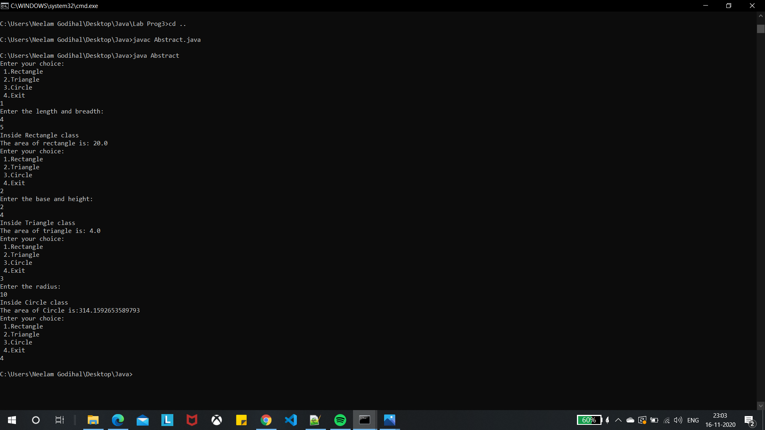

**WEEK 5:**

Develop a Java program to create a class Bank that maintains two kinds of account for its customers, one called savings account and the other current account. The savings account provides compound interest and withdrawal facilities but no cheque book facility. The current account provides cheque book facility but no interest. Current account holders should also maintain a minimum balance and if the balance falls below this level, a service charge is imposed. Create a class Account that stores customer name, account number and type of account. From this derive the classes Curr-acct and Sav-acct to make them more specific to their requirements. Include the necessary methods in order to achieve the following tasks: a) Accept deposit from customer and update the balance. a) Display the balance. b) Compute and deposit interest c) Permit withdrawal and update the balance d) Check for the minimum balance, impose penalty if necessary and update the balance

**WRITEUP:**

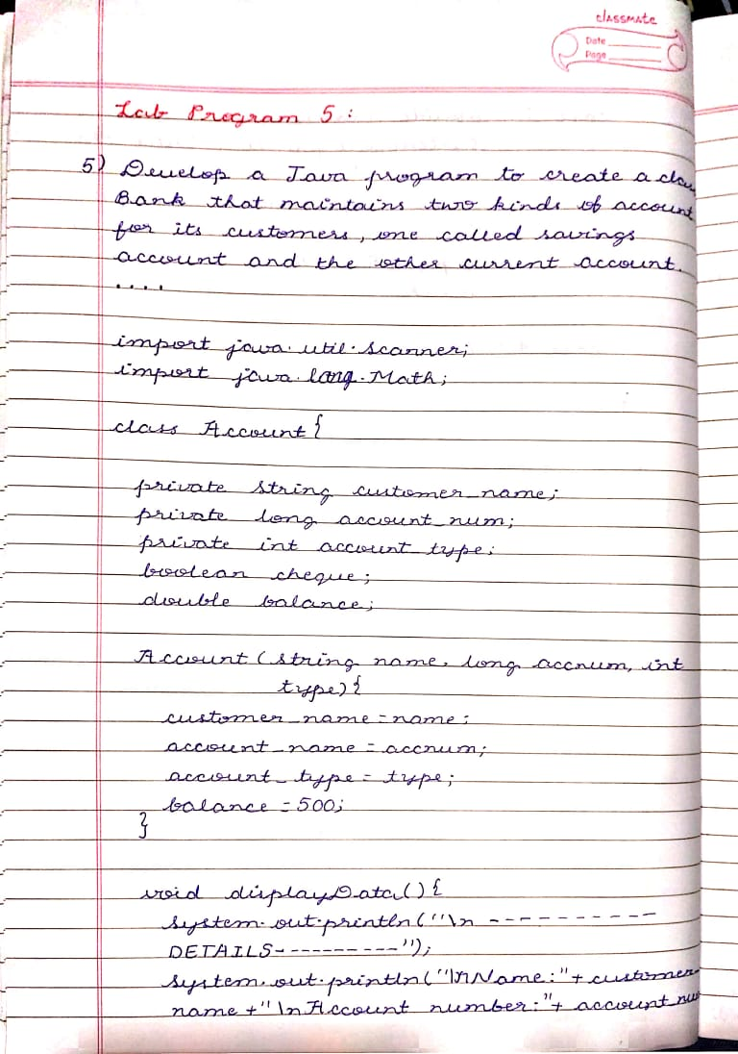

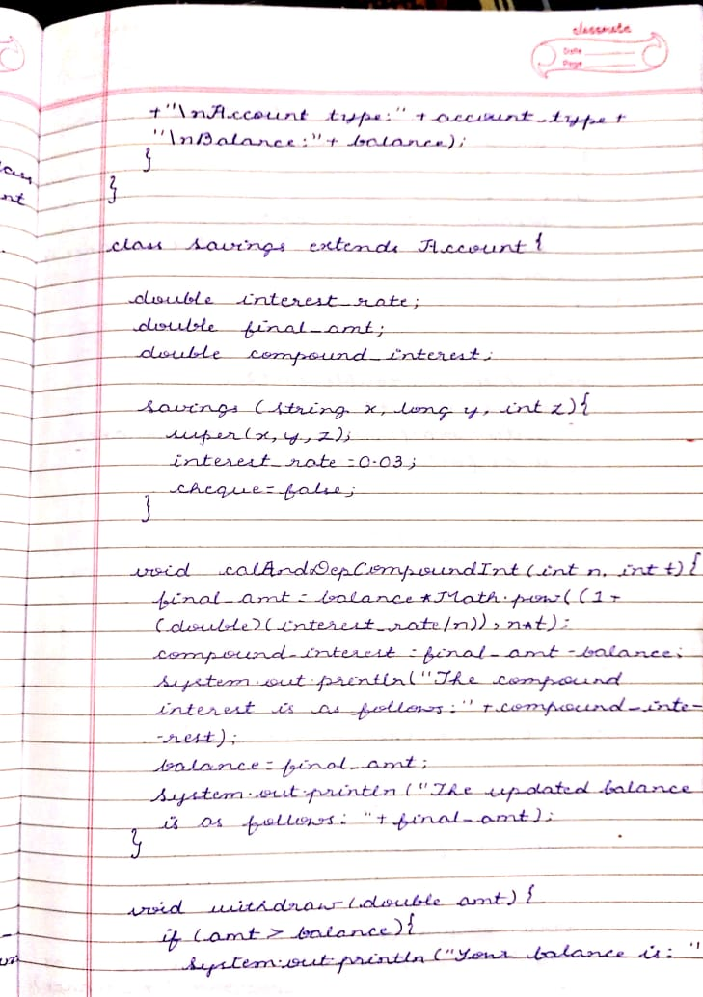

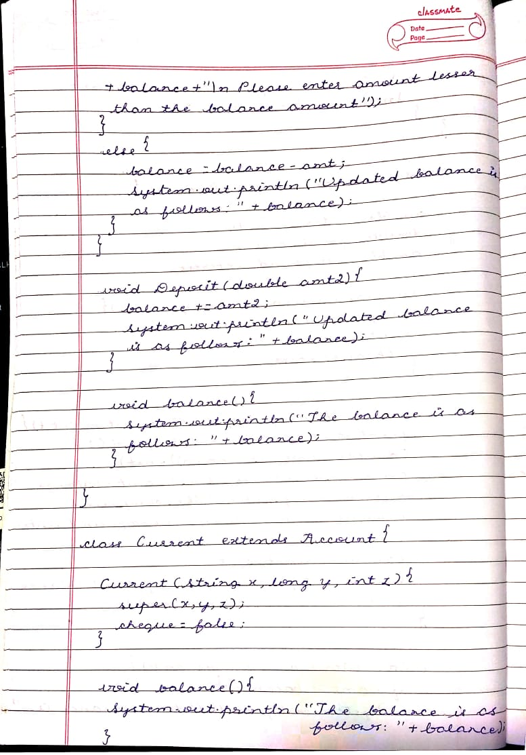

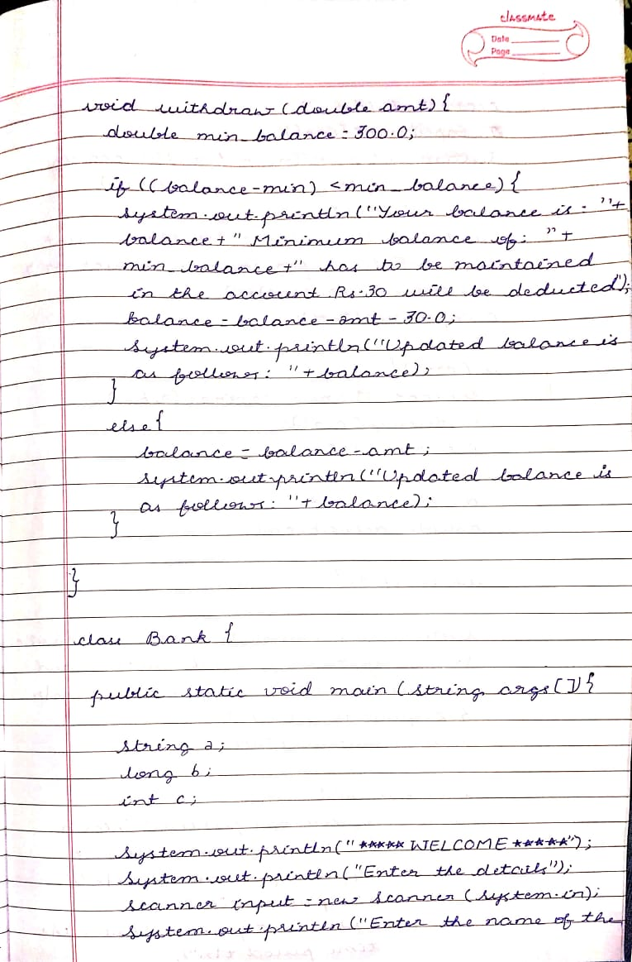

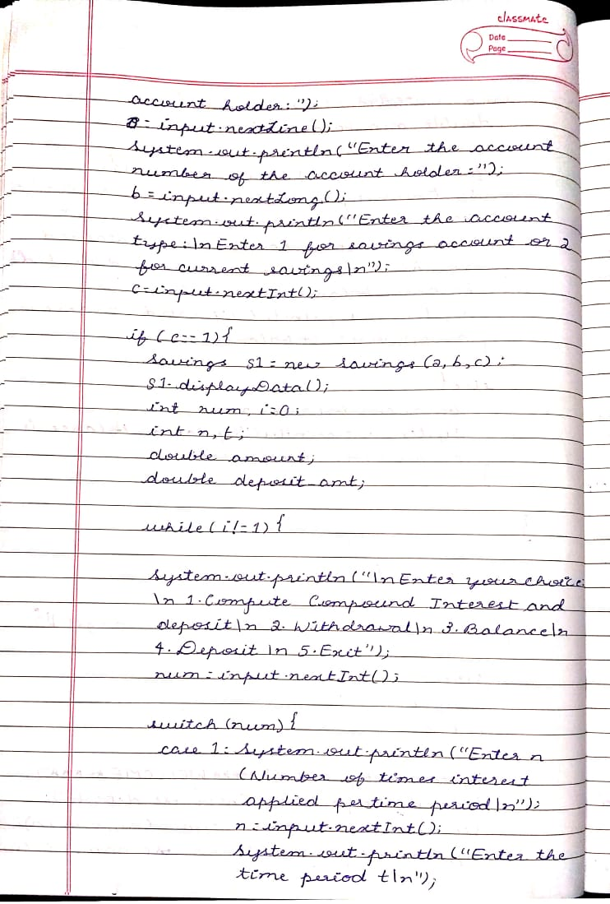

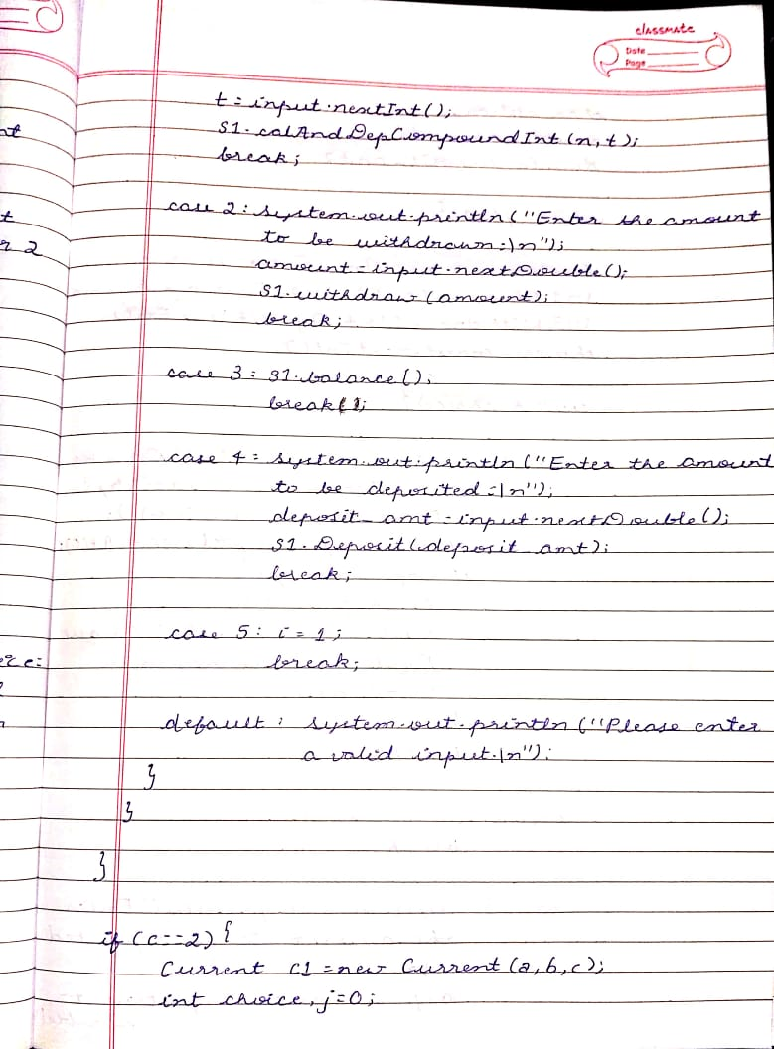

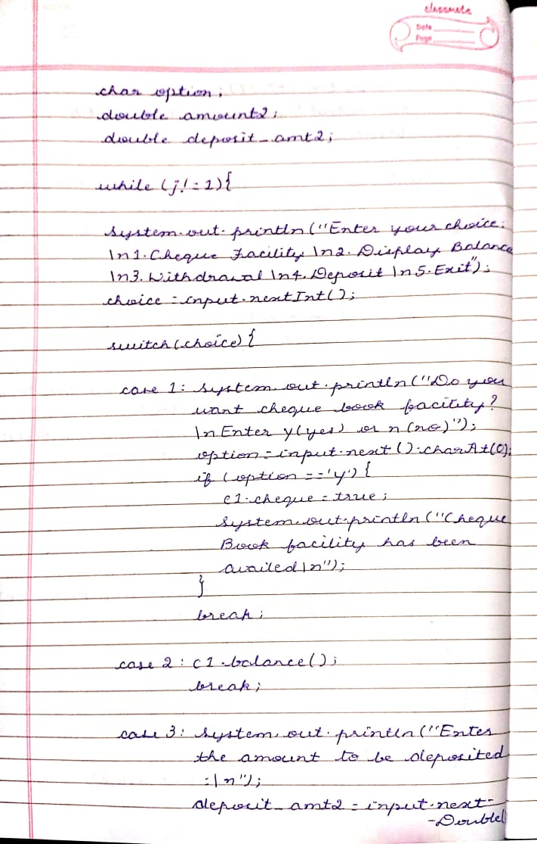

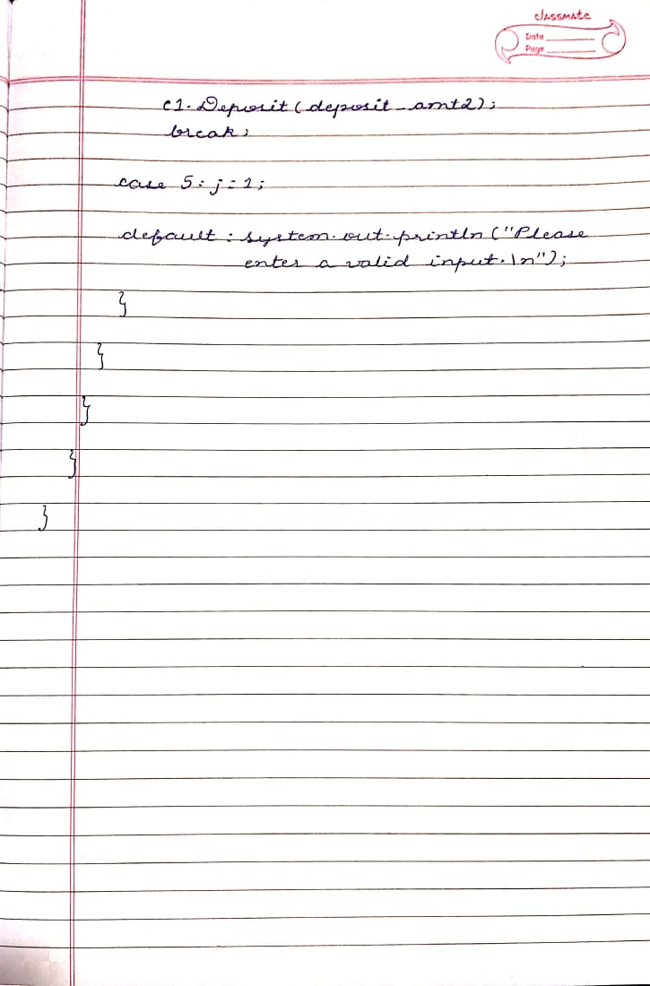

**SOURCE CODE:**

**import java.util.Scanner;**

**import java.lang.Math;**

**class Account{**

**private String customer_name;**

**private long account_num;**

**private int account_type;**

**boolean cheque;**

**double balance;**

**Account(String name,long accnum,int type){**

**customer_name=name;**

**account_num=accnum;**

**account_type=type;**

**balance=500;**

**}**

**void displayData(){**

**System.out.println("\n----------DETAILS----------");**

**System.out.println("\nName:"+customer_name+"\nAccount number:"+account_num+"\nAccount type:"+account_type+"\nBalance:"+balance);**

**}**

**}**

**class Savings extends Account{**

**double interest_rate;**

**double final_amt;**

**double compound_interest;**

**Savings(String x,long y,int z){**

**super(x,y,z);**

**interest_rate=0.03;**

**cheque=false;**

**}**

**void calAndDepCompoundInt(int n,int t){**

**final_amt=balance*Math.pow((1 + (double)(interest_rate/n)),n*t);**

**compound_interest = final_amt - balance;**

**System.out.println("The compound interest is as follows:"+compound_interest);**

**balance = final_amt;**

**System.out.println("The updated balance is as follows: "+final_amt);**

**}**

**void withdraw(double amt){**

**if(amt>balance){**

**System.out.println("Your balance is : "+balance+"\n Please enter amount lesser than the balance amount");**

**}**

**else {**

**balance=balance-amt;**

**System.out.println("Updated balance is as follows: "+balance);**

**}**

**}**

**void Deposit(double amt2){**

**balance+=amt2;**

**System.out.println("Updated balance is as follows: "+balance);**

**}**

**void balance(){**

**System.out.println("The balance is as follows: "+balance);**

**}**

**}**

**class Current extends Account{**

**Current(String x,long y,int z){**

**super(x,y,z);**

**cheque=false;**

**}**

**void balance(){**

**System.out.println("The balance is as follows: "+balance);**

**}**

**void withdraw(double amt){**

**double min_balance=300.0;**

**if((balance-amt)<min_balance){**

**System.out.println("Your balance is : "+balance+" Minimum balance of: "+min_balance+" has to be maintained in the account.Rs.30 will be deducted.");**

**balance=balance-amt-30.0;**

**System.out.println("Updated balance is as follows: "+balance);**

**}**

**else {**

**balance=balance-amt;**

**System.out.println("Updated balance is as follows: "+balance);**

**}**

**}**

**void Deposit(double amt3){**

**balance+=amt3;**

**System.out.println("Updated balance is as follows: "+balance);**

**}**

**}**

**class Bank {**

**public static void main(String args[]){**

**String a;**

**long b;**

**int c;**

**System.out.println("*****WELCOME*****");**

**System.out.println("Enter the details");**

**Scanner input=new Scanner(System.in);**

**System.out.println("Enter the name of the account holder:");**

**a=input.nextLine();**

**System.out.println("Enter the account number of the account holder:");**

**b=input.nextLong();**

**System.out.println("Enter the account type:\nEnter 1 for savings account or 2 for current savings\n");**

**c=input.nextInt();**

**if(c==1){**

**Savings s1=new Savings(a,b,c);**

**s1.displayData();**

**int num,i=0;**

**int n,t;**

**double amount;**

**double deposit_amt;**

**while(i!=1){**

**System.out.println("\nEnter your choice:\n 1.Compute Compound Interest and deposit\n 2.Withdrawal\n 3.Balance \n 4.Deposit \n 5.Exit");**

**num=input.nextInt();**

**switch(num){**

**case 1:System.out.println("Enter n(Number of times interest applied per time period)\n");**

**n=input.nextInt();**

**System.out.println("Enter the time period t\n");**

**t=input.nextInt();**

**s1.calAndDepCompoundInt(n,t);**

**break;**

**case 2:System.out.println("Enter the amount to be withdrawn:\n");**

**amount=input.nextDouble();**

**s1.withdraw(amount);**

**break;**

**case 3:s1.balance();**

**break;**

**case 4:System.out.println("Enter the amount to be deposited:\n");**

**deposit_amt=input.nextDouble();**

**s1.Deposit(deposit_amt);**

**break;**

**case 5:i=1;**

**break;**

**default: System.out.println("Please enter a valid input.\n");**

**}**

**}**

**}**

**if(c==2){**

**Current c1=new Current(a,b,c);**

**int choice,j=0;**

**char option;**

**double amount2;**

**double deposit_amt2;**

**while(j!=1){**

**System.out.println("Enter your choice:\n1.Cheque Facility \n2.Display Balance \n3.Withdrawal\n4.Deposit\n5.Exit ");**

**choice=input.nextInt();**

**switch(choice){**

**case 1: System.out.println("Do you want cheque book facility?\n Enter y(yes) or n(no)");**

**option=input.next().charAt(0);**

**if(option=='y'){**

**c1.cheque=true;**

**System.out.println("Cheque Book facility has been availed\n");**

**}**

**break;**

**case 2: c1.balance();**

**break;**

**case 3: System.out.println("Enter the amount to be withdrawn:\n");**

**amount2=input.nextDouble();**

**c1.withdraw(amount2);**

**break;**

**case 4:System.out.println("Enter the amount to be deposited:\n");**

**deposit_amt2=input.nextDouble();**

**c1.Deposit(deposit_amt2);**

**break;**

**case 5: j=1;**

**break;**

**default: System.out.println("Please enter a valid input.\n");**

**}**

**}**

**}**

**}**

**}**

**OUTPUT:**

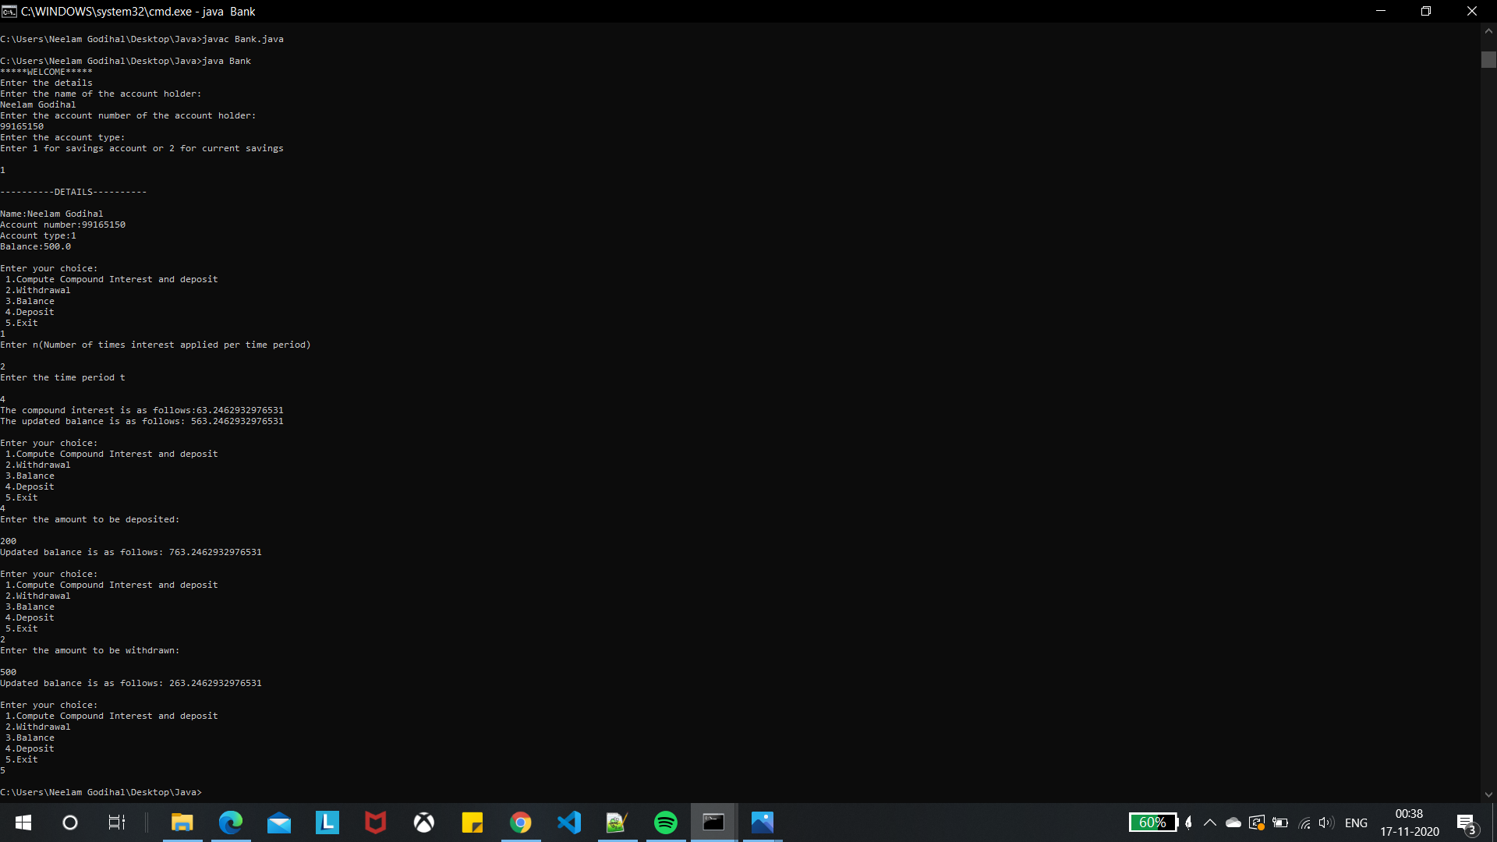

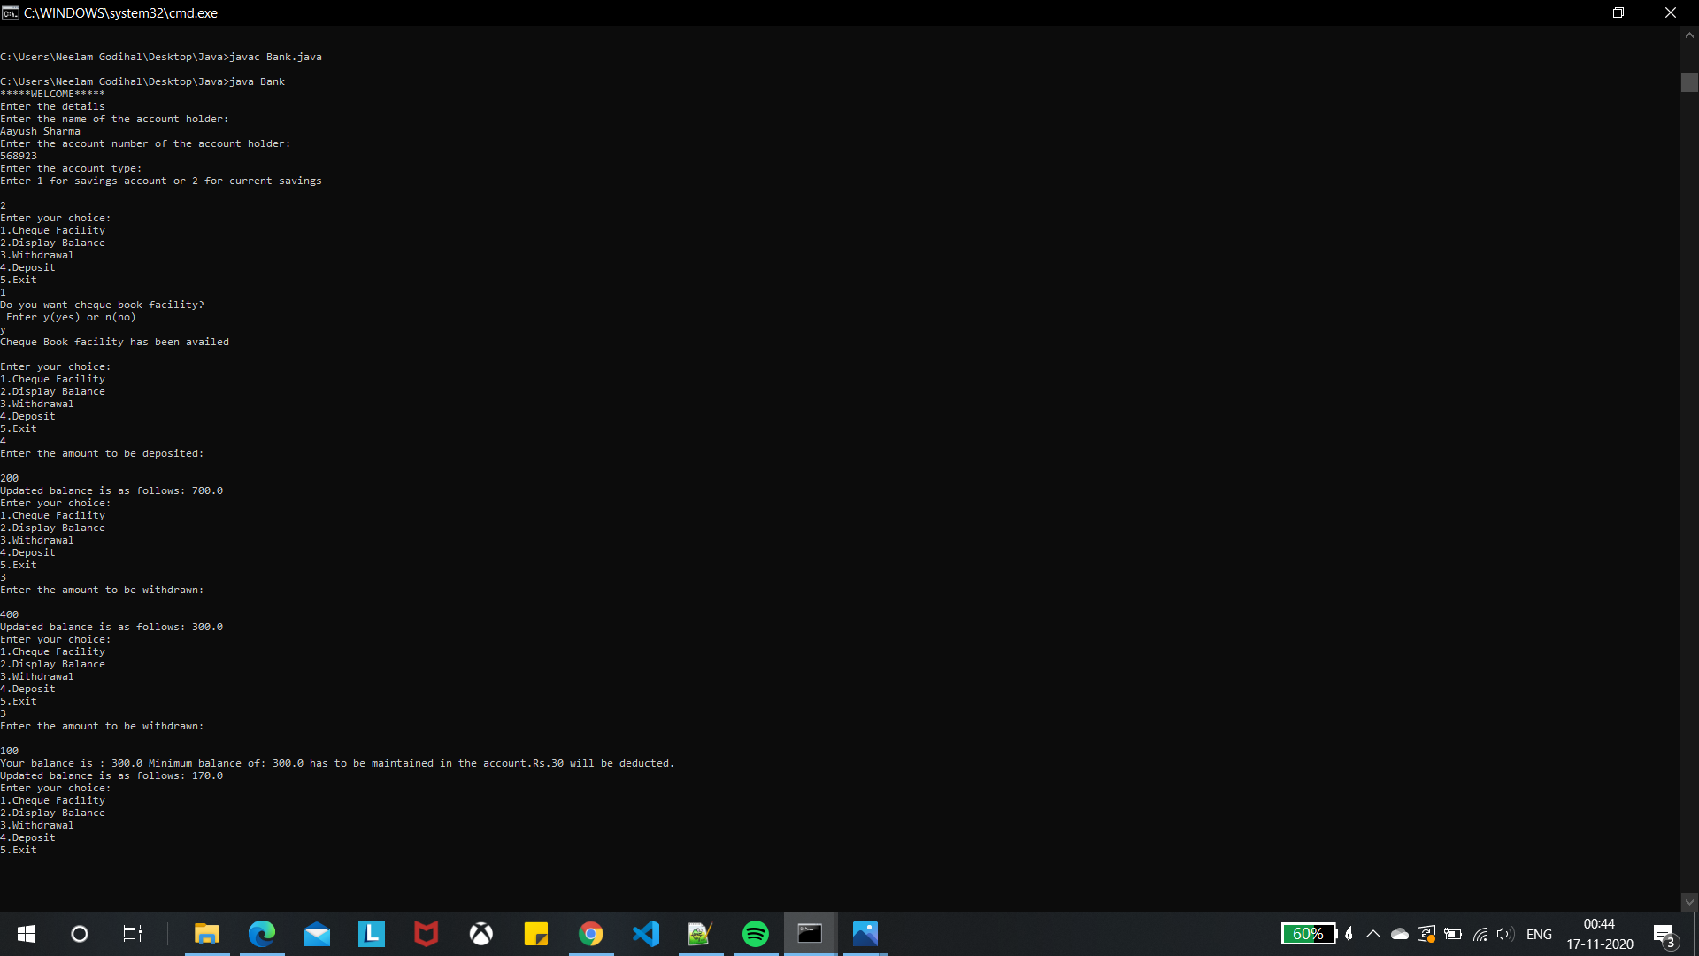

**WEEK 6:**

Create a package CIE which has two classes- Student and Internals. The class Personal has members like usn, name, sem. The class internals has an array that stores the internal marks scored in five courses of the current semester of the student. Create another package SEE which has the class External which is a derived class of Student. This class has an array that stores the SEE marks scored in five courses of the current semester of the student. Import the two packages in a file that declares the final marks of n students in all five courses.

**WRITEUP:**

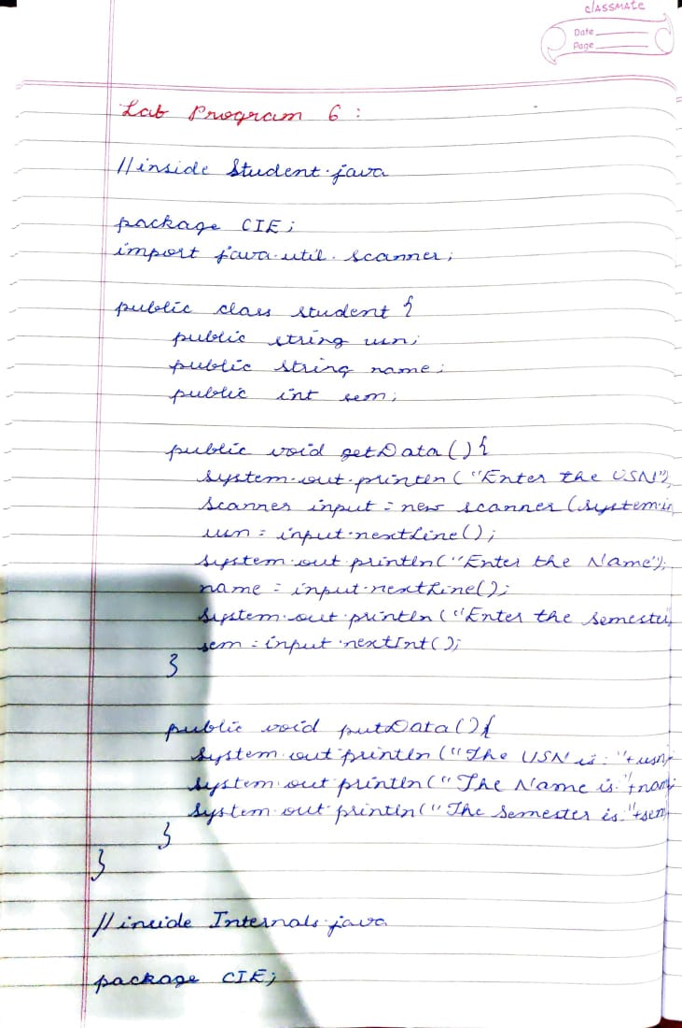

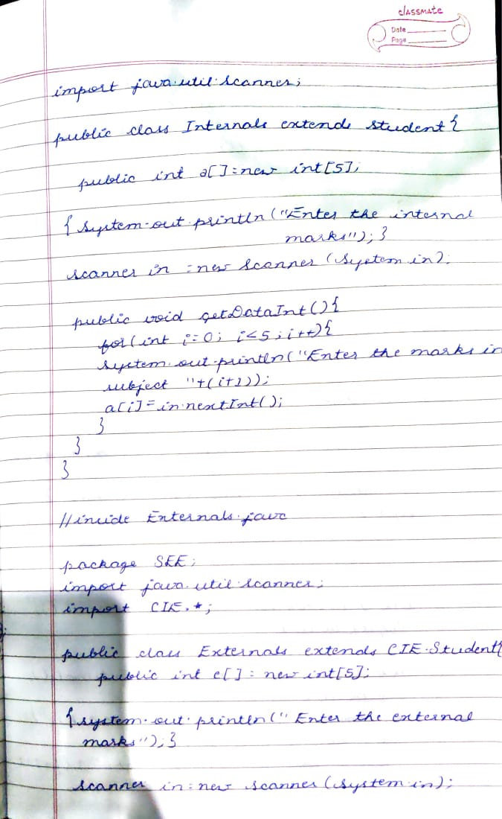

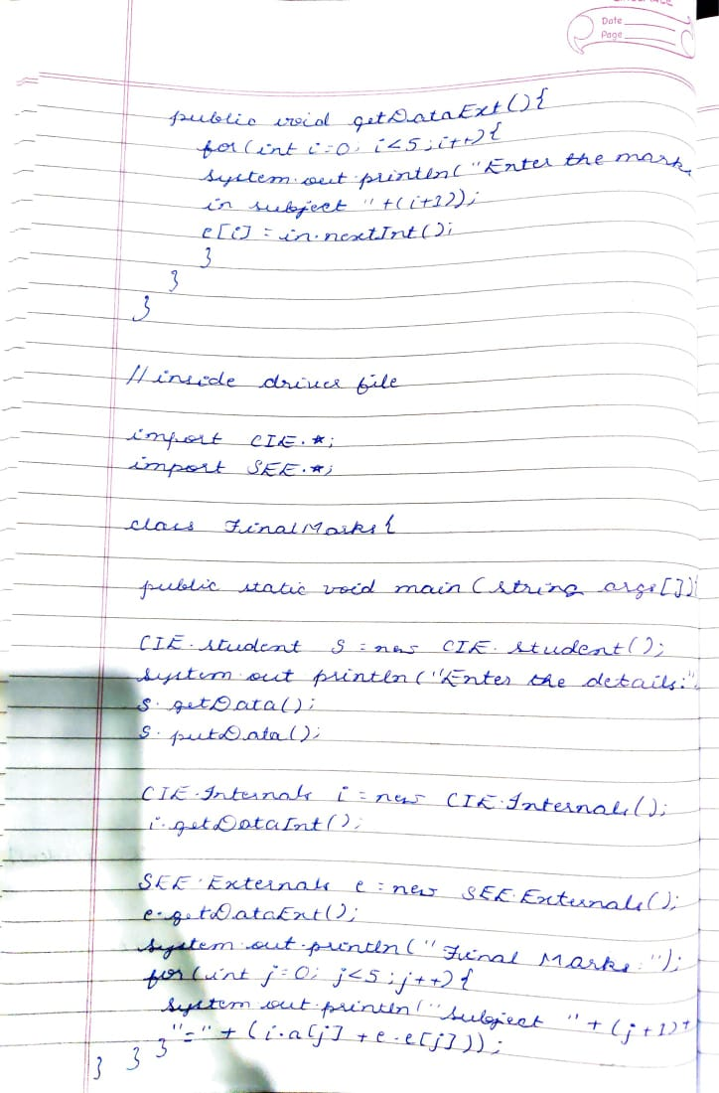

**SOURCE CODE:**

|  |  |
| --- | --- |
| **//inside Student.java** |  |
|  | **package CIE;** |
|  | **import java.util.Scanner;** |
|  |  |
|  | **public class Student{** |
|  | **public String usn;** |
|  | **public String name;** |
|  | **public int sem;** |
|  |  |
|  | **/*Student(){** |
|  | **usn="";** |
|  | **name="";** |
|  | **sem=0;** |
|  | **}** |
|  |  |
|  | **Student(String u,String n,int s){** |
|  | **usn=u;** |
|  | **name=n;** |
|  | **sem=s;** |
|  | **}*/** |
|  |  |
|  | **public void getData(){** |
|  | **System.out.println("Enter the USN");** |
|  | **Scanner input=new Scanner(System.in);** |
|  | **usn=input.nextLine();** |
|  | **System.out.println("Enter the Name");** |
|  | **name=input.nextLine();** |
|  | **System.out.println("Enter the Semester");** |
|  | **sem=input.nextInt();** |
|  | **}** |
|  |  |
|  | **public void putData(){** |
|  | **System.out.println("The USN is:"+usn);** |
|  | **System.out.println("The Name is:"+name);** |
|  | **System.out.println("The Semester is:"+sem);** |
|  | **}** |
|  |  |
|  | **}** |
|  |  |
|  | **//inside Internals.java** |
|  | **package CIE;** |
|  | **import java.util.Scanner;** |
|  |  |
|  | **public class Internals extends Student{** |
|  | **public int a[]=new int[5];** |
|  |  |
|  | **{System.out.println("Enter the internal marks");}** |
|  | **Scanner in=new Scanner(System.in);** |
|  |  |
|  | **public void getDataInt(){** |
|  | **for(int i=0;i<5;i++){** |
|  | **System.out.println("Enter the marks in subject "+(i+1));** |
|  | **a[i]=in.nextInt();** |
|  | **}** |
|  | **}** |
|  | **}** |
|  |  |
|  | **//inside Externals.java** |
|  | **package SEE;** |
|  | **import java.util.Scanner;** |
|  | **import CIE.*;** |
|  |  |
|  | **public class Externals extends CIE.Student{** |
|  | **public int e[]=new int[5];** |
|  | **{System.out.println("Enter the external marks");}** |
|  | **Scanner in=new Scanner(System.in);** |
|  |  |
|  | **public void getDataExt(){** |
|  | **for(int i=0;i<5;i++){** |
|  | **System.out.println("Enter the marks in subject "+(i+1));** |
|  | **e[i]=in.nextInt();** |
|  | **}** |
|  | **}** |
|  | **}** |
|  |  |
|  | **//inside driver file** |
|  | **import CIE.*;** |
|  | **import SEE.*;** |
|  |  |
|  | **class FinalMarks{** |
|  |  |
|  | **public static void main(String args[]){** |
|  | **CIE.Student s=new CIE.Student();** |
|  | **System.out.println("Enter your details:");** |
|  | **s.getData();** |
|  | **s.putData();** |
|  |  |
|  | **CIE.Internals i=new CIE.Internals();** |
|  | **//i.Internals();** |
|  | **i.getDataInt();** |
|  |  |
|  | **SEE.Externals e=new SEE.Externals();** |
|  | **e.getDataExt();** |
|  |  |
|  | **System.out.println("Final Marks:");** |
|  | **for(int j=0;j<5;j++){** |
|  | **System.out.println("Subject "+(j+1)+"="+(i.a[j]+e.e[j]));** |
|  | **}** |
|  | **}** |
|  | **}** |

**OUTPUT:**

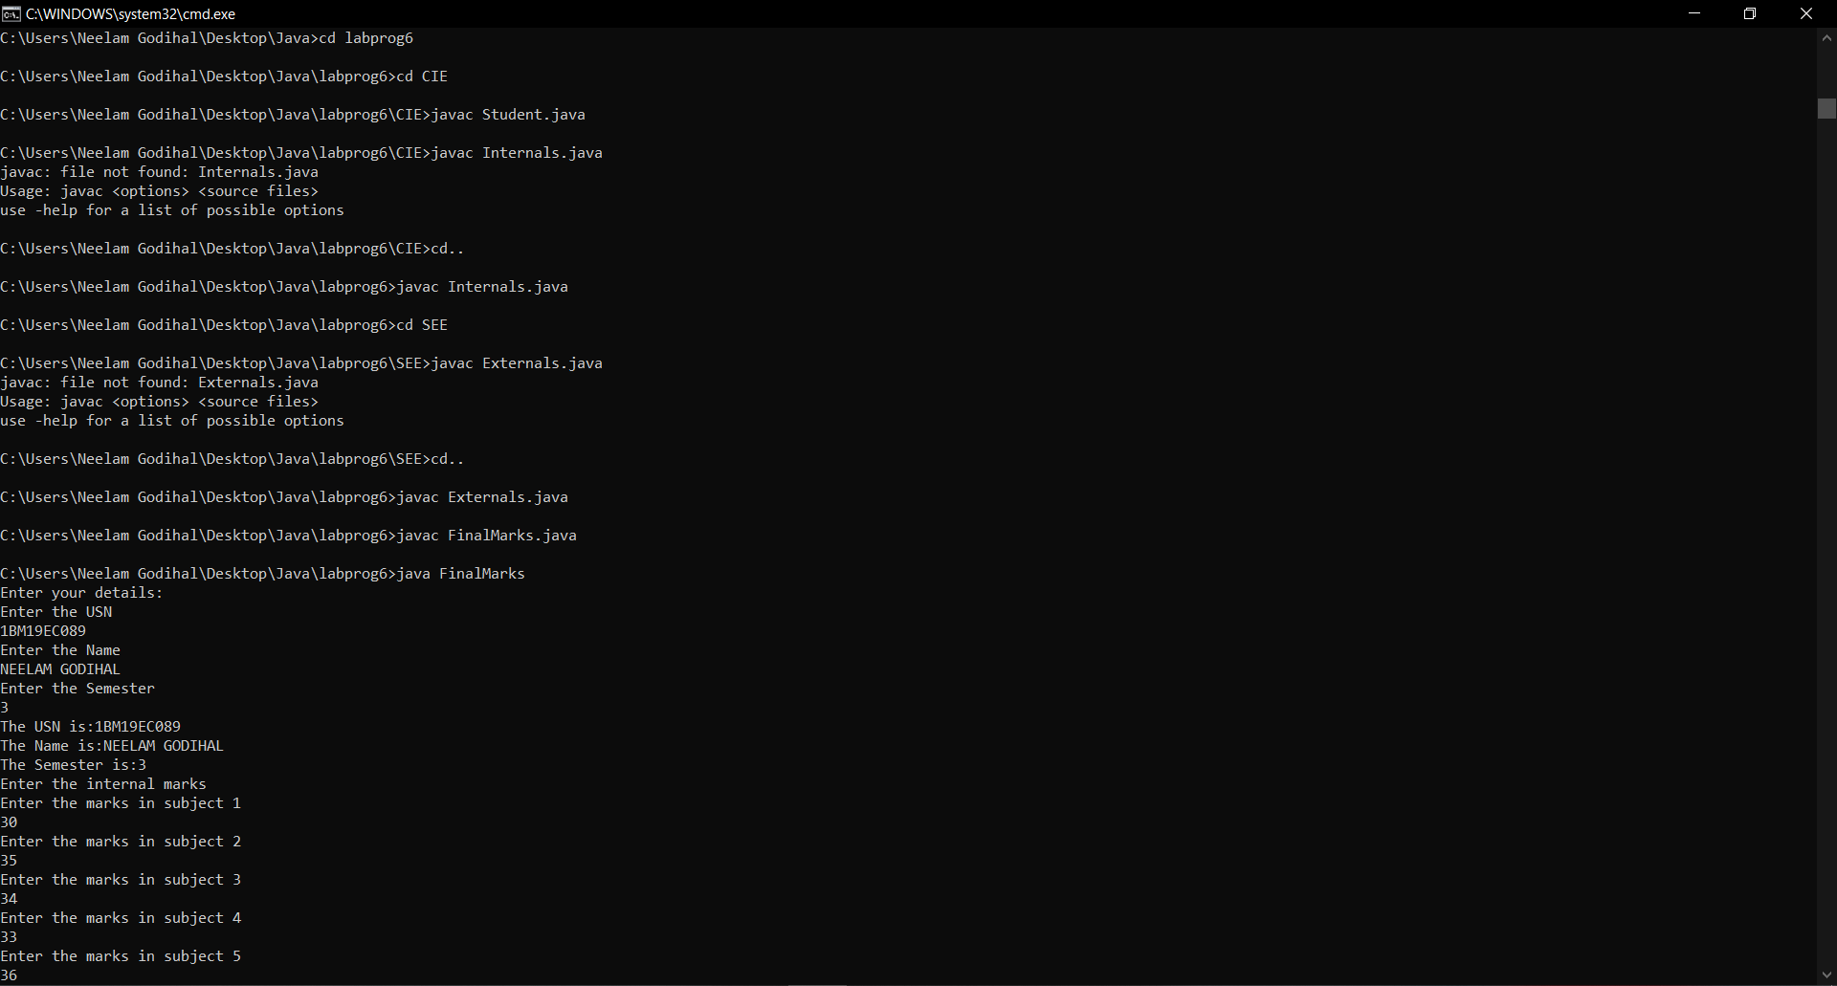

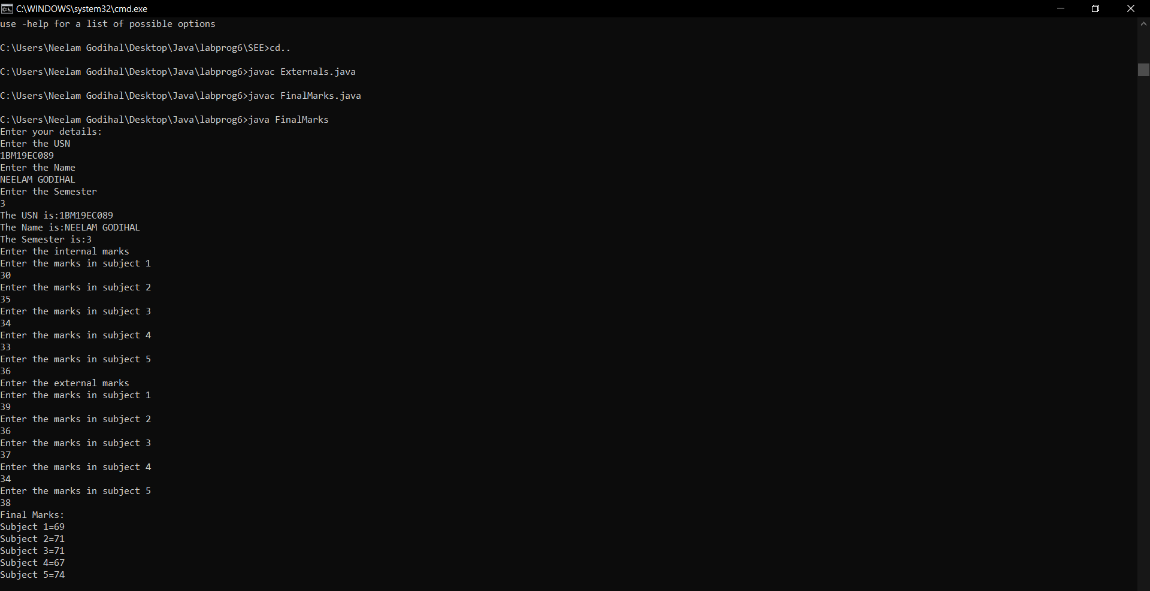

**WEEK 7:**

Write a program to demonstrate generics with multiple object parameters.

**WRITEUP:**

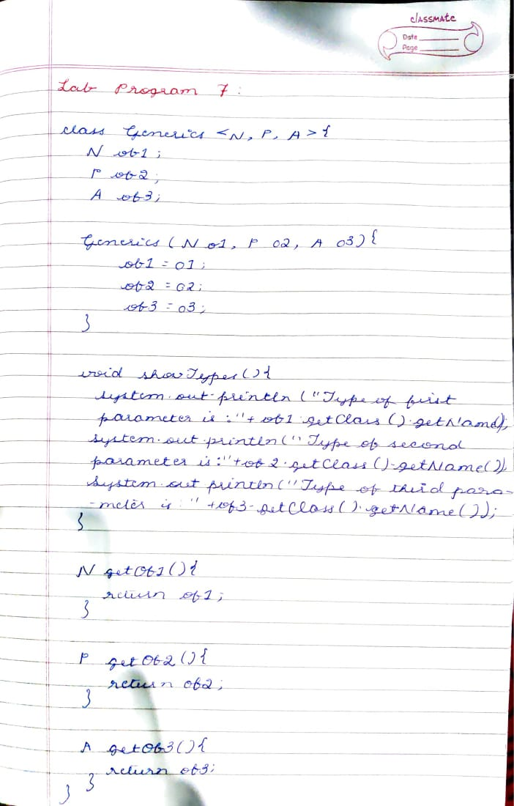

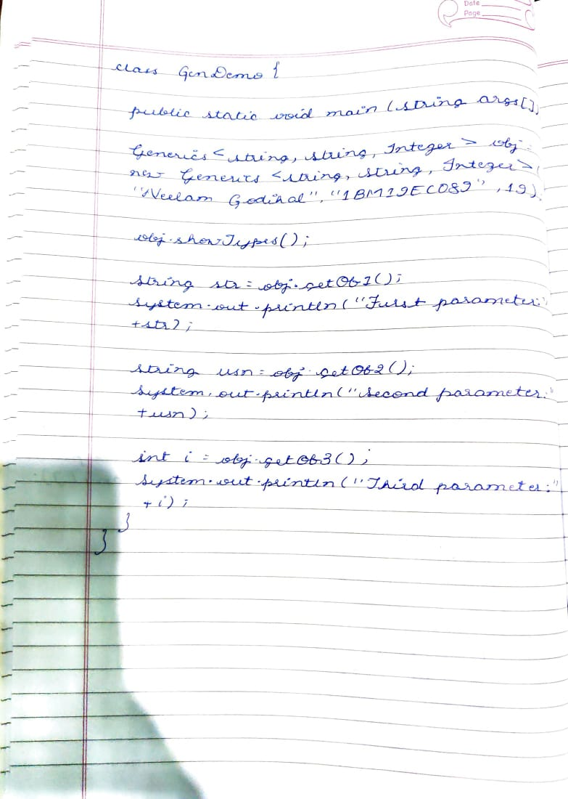

**SOURCE CODE:**

|  |  |
| --- | --- |
| **class Generics<N,P,A>{** |  |
|  | **N ob1;** |
|  | **P ob2;** |
|  | **A ob3;** |
|  |  |
|  | **Generics(N o1,P o2,A o3){** |
|  | **ob1=o1;** |
|  | **ob2=o2;** |
|  | **ob3=o3;** |
|  | **}** |
|  |  |
|  | **void showTypes(){** |
|  | **System.out.println("Type of first parameter is:"+ob1.getClass().getName());** |
|  | **System.out.println("Type of second parameter is:"+ob2.getClass().getName());** |
|  | **System.out.println("Type of third parameter is:"+ob3.getClass().getName());** |
|  | **}** |
|  |  |
|  | **N getOb1(){** |
|  | **return ob1;** |
|  | **}** |
|  |  |
|  | **P getOb2(){** |
|  | **return ob2;** |
|  | **}** |
|  |  |
|  | **A getOb3(){** |
|  | **return ob3;** |
|  | **}** |
|  | **}** |
|  |  |
|  | **class GenDemo{** |
|  | **public static void main(String args[]){** |
|  | **Generics<String,String,Integer> obj= new Generics<String,String,Integer>("Neelam Godihal","1BM19EC089",19);** |
|  |  |
|  | **obj.showTypes();** |
|  |  |
|  | **String str=obj.getOb1();** |
|  | **System.out.println("First parameter:"+str);** |
|  |  |
|  | **String usn=obj.getOb2();** |
|  | **System.out.println("Second parameter:"+usn);** |
|  |  |
|  | **int i=obj.getOb3();** |
|  | **System.out.println("Third parameter:"+i);** |
|  | **}** |
|  |  |
| **OUTPUT:** | **}** |

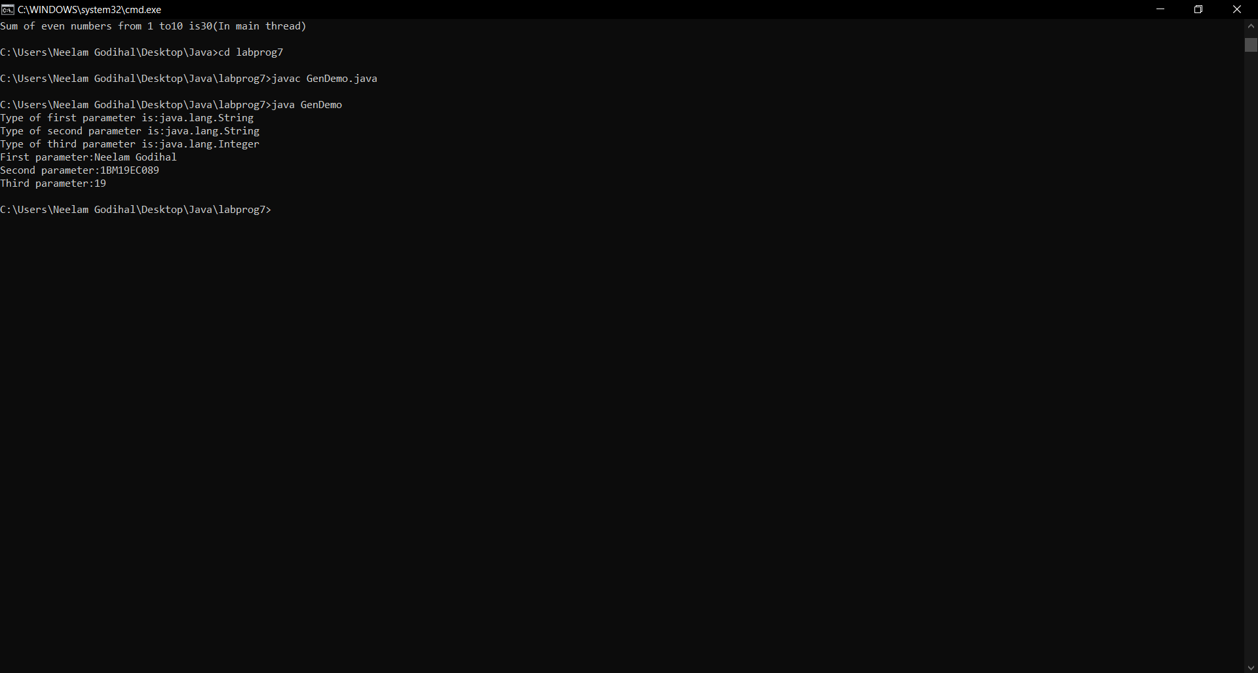

**WEEK 8:**

Write a program that demonstrates handling of exceptions in inheritance tree. Create a base class called “Father” and derived class called “Son” which extends the base class. In Father class, implement a constructor which takes the age and throws the exception Wrong Age( ) when the input age<0. In Son class, implement a constructor that cases both father and son’s age and throws an exception if son’s age is >=father’s age.

**WRITEUP:**

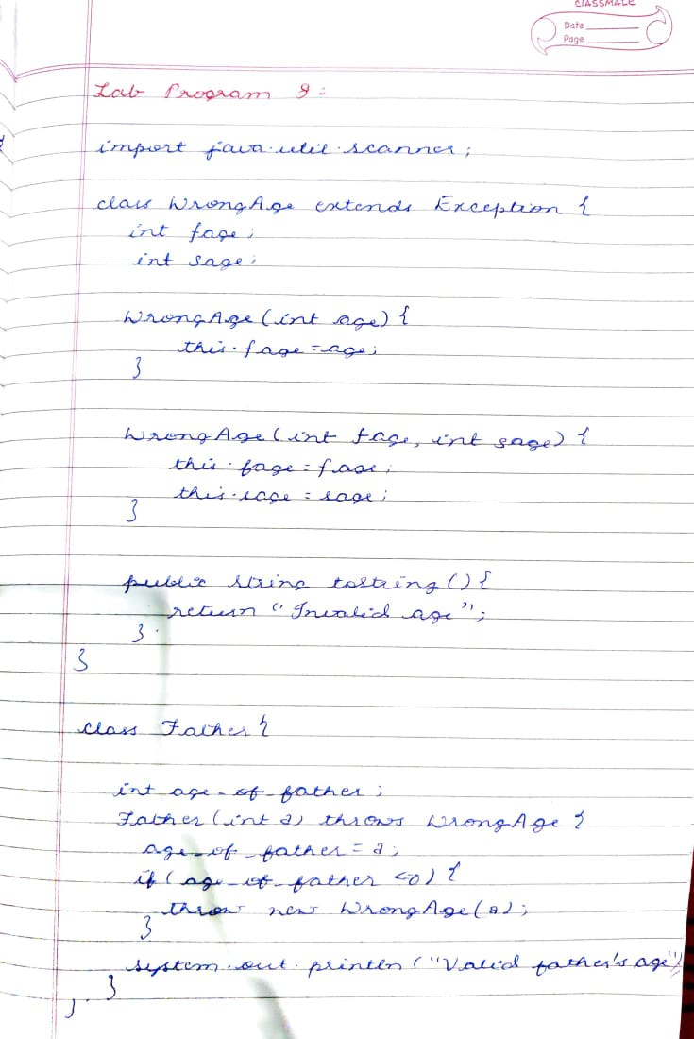

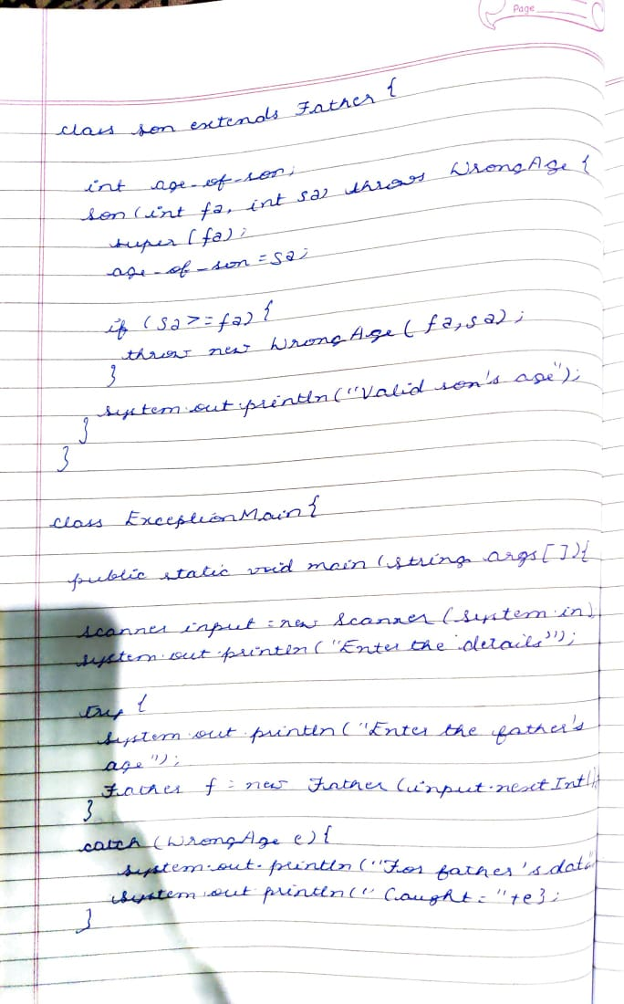

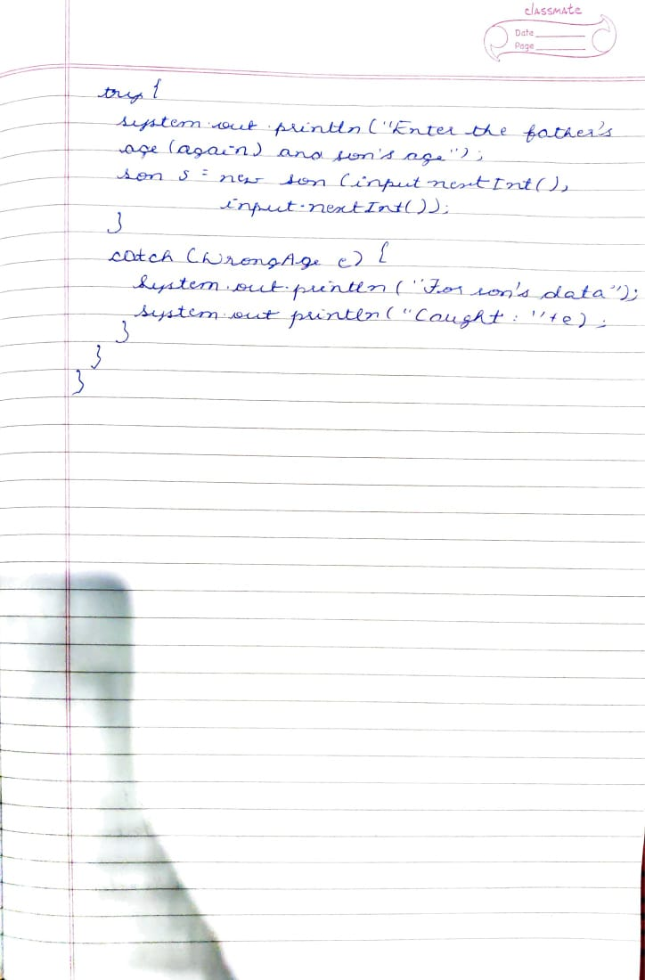

**SOURCE CODE:**

|  |  |
| --- | --- |
| **import java.util.Scanner;** |  |
|  |  |
|  | **class WrongAge extends Exception{** |
|  | **int fage;** |
|  | **int sage;** |
|  |  |
|  | **WrongAge(int age){** |
|  | **this.fage=age;** |
|  | **}** |
|  |  |
|  | **WrongAge(int fage,int sage){** |
|  | **this.fage=fage;** |
|  | **this.sage=sage;** |
|  | **}** |
|  |  |
|  | **public String toString(){** |
|  | **return "Invalid age";** |
|  | **}** |
|  |  |
|  | **}** |
|  |  |
|  | **class Father{** |
|  |  |
|  | **int age_of_father;** |
|  | **Father(int a) throws WrongAge{** |
|  | **age_of_father=a;** |
|  | **if(age_of_father<=0){** |
|  | **throw new WrongAge(a);** |
|  | **}** |
|  | **System.out.println("Valid father's age.");** |
|  | **}** |
|  | **}** |
|  |  |
|  |  |
|  | **class Son extends Father{** |
|  |  |
|  | **int age_of_son;** |
|  | **Son(int fa,int sa)throws WrongAge{** |
|  | **super(fa);** |
|  | **age_of_son=sa;** |
|  |  |
|  | **if(sa>=fa){** |
|  | **throw new WrongAge(fa,sa);** |
|  | **}** |
|  | **System.out.println("Valid son's age.");** |
|  | **}** |
|  | **}** |
|  |  |
|  | **class ExceptionMain{** |
|  | **public static void main(String args[]){** |
|  | **Scanner input=new Scanner(System.in);** |
|  | **System.out.println("Enter the details:");** |
|  | **try{** |
|  | **System.out.println("Enter the father's age");** |
|  | **Father f=new Father(input.nextInt());** |
|  | **}** |
|  | **catch(WrongAge e){** |
|  | **System.out.println("For father's data");** |
|  | **System.out.println("Caught: "+e);** |
|  | **}** |
|  |  |
|  | **try{** |
|  | **System.out.println("Enter the father's age(again) and son's age");** |
|  | **Son s=new Son(input.nextInt(),input.nextInt());** |
|  | **}** |
|  | **catch(WrongAge e){** |
|  | **System.out.println("For son's data");** |
|  | **System.out.println("Caught: "+e);** |
|  | **}** |
|  | **}** |
|  | **}**  **OUTPUT:** |

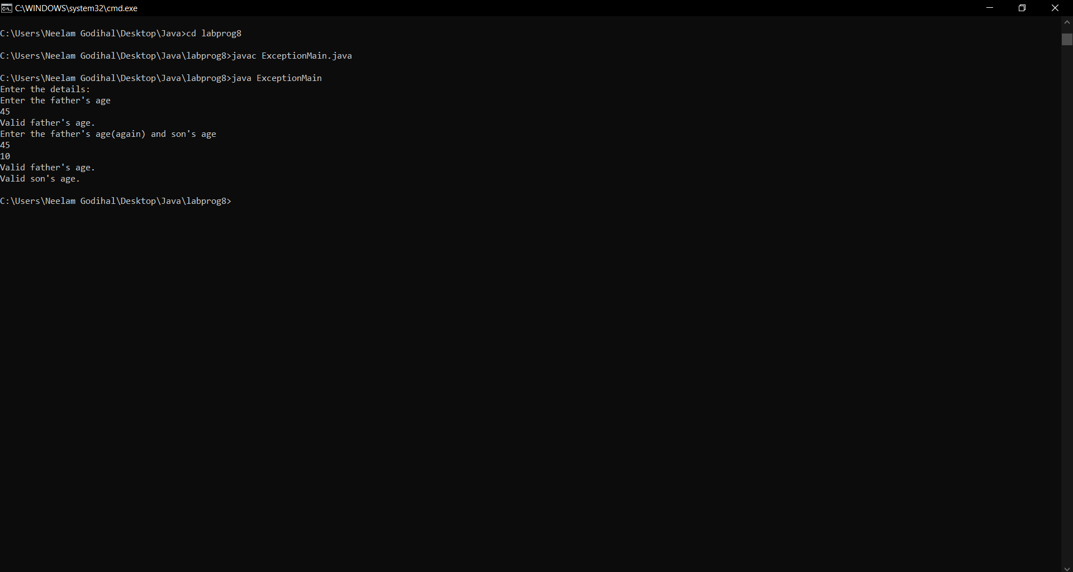

**WEEK 9:**

**WRITEUP:**

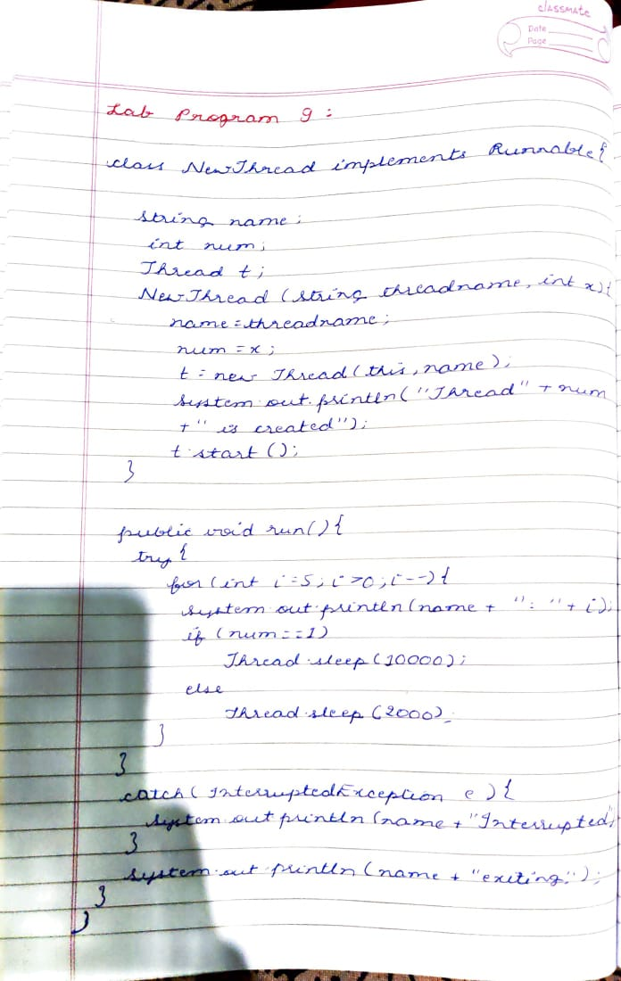



**SOURCE CODE:**

|  |  |
| --- | --- |
| **class NewThread**  **implements Runnable** |  |
|  | **{** |
|  | **String name;** |
|  | **int num;** |
|  | **Thread t;** |
|  | **NewThread(String threadname,int x)** |
|  | **{** |
|  | **name=threadname;** |
|  | **num=x;** |
|  | **t = new Thread(this, name);** |
|  | **System.out.println("Thread" + num +" is created" );** |
|  | **t.start();** |
|  | **}** |
|  | **public void run()** |
|  | **{** |
|  | **try** |
|  | **{** |
|  | **for(int i = 5; i > 0; i--)** |
|  | **{** |
|  | **System.out.println(name + ": " + i);** |
|  | **if(num==1)** |
|  | **Thread.sleep(10000);** |
|  | **else** |
|  | **Thread.sleep(2000);** |
|  | **}** |
|  | **}** |
|  | **catch(InterruptedException e)** |
|  | **{** |
|  | **System.out.println(name + "Interrupted");** |
|  | **}** |
|  | **System.out.println(name + " exiting.");** |
|  | **}** |
|  | **}** |
|  |  |
|  |  |
|  | **class threadmain** |
|  | **{** |
|  | **public static void main(String args[])** |
|  | **{** |
|  | **new NewThread("BMS College of Engineering",1);** |
|  | **new NewThread("CSE",2);** |
|  | **}** |
|  | **}**  **OUTPUT:** |

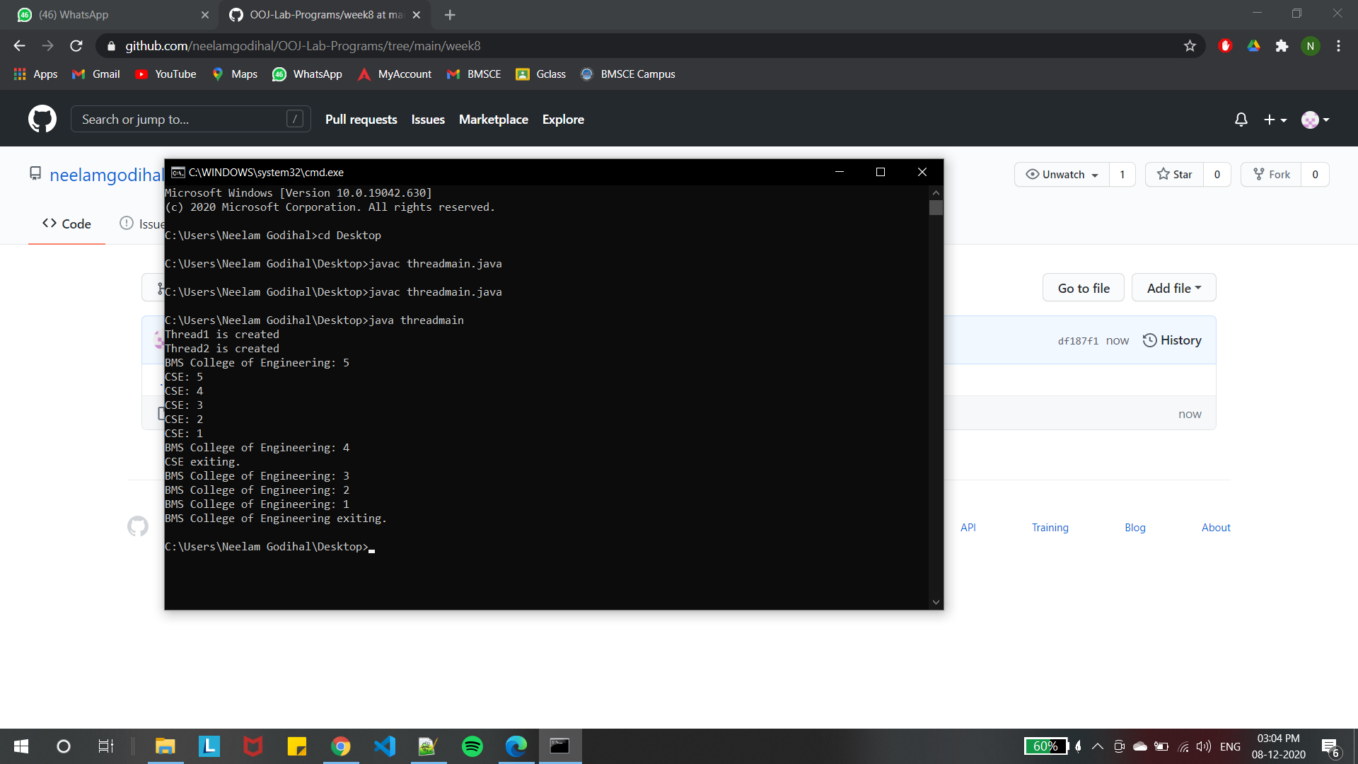

**WEEK 10:**

**WRITEUP:**

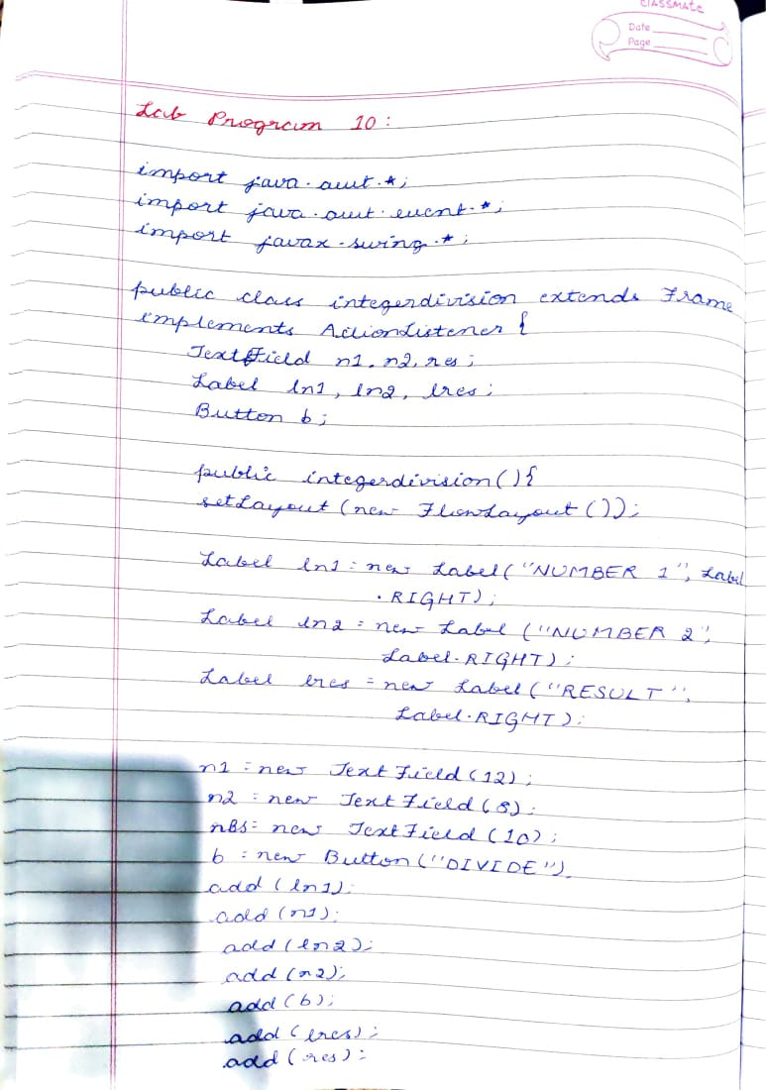

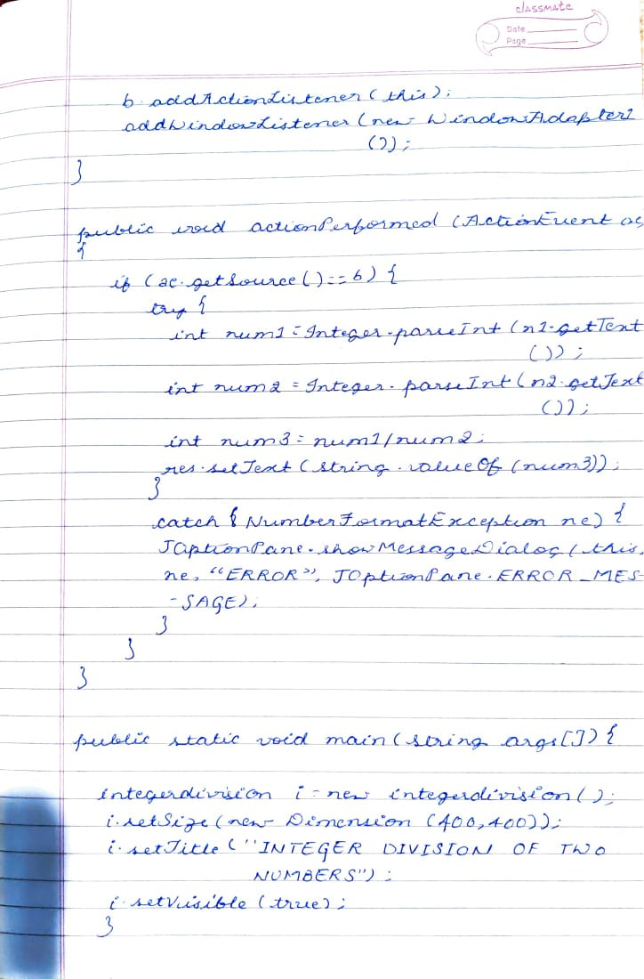

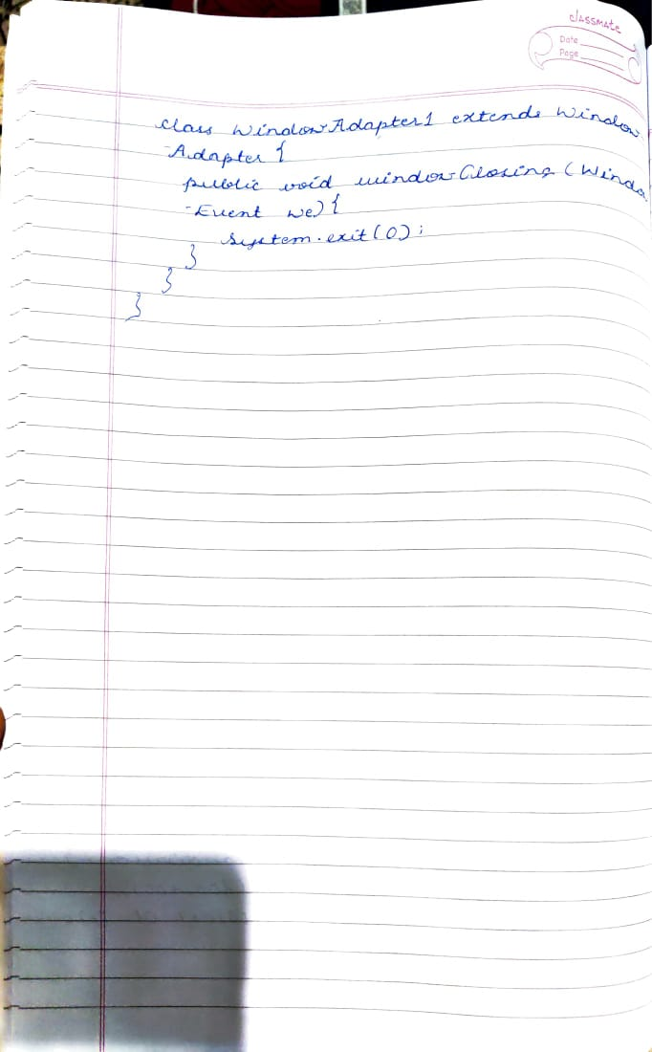

**SOURCE CODE:**

|  |  |
| --- | --- |
| **import java.awt.*;** |  |
|  | **import java.awt.event.*;** |
|  | **import javax.swing.*;** |
|  | **public class integerdivision extends Frame implements ActionListener{** |
|  | **TextField n1,n2,res;** |
|  | **Label ln1,ln2,lres;** |
|  | **Button b;** |
|  | **public integerdivision(){** |
|  | **setLayout(new FlowLayout());** |
|  | **Label ln1=new Label("NUMBER 1",Label.RIGHT);** |
|  | **Label ln2=new Label("NUMBER 2",Label.RIGHT);** |
|  | **Label lres=new Label("RESULT",Label.RIGHT);** |
|  | **n1=new TextField(12);** |
|  | **n2=new TextField(8);** |
|  | **res=new TextField(10);** |
|  | **b=new Button("DIVIDE");** |
|  | **add(ln1);** |
|  | **add(n1);** |
|  | **add(ln2);** |
|  | **add(n2);** |
|  | **add(b);** |
|  | **add(lres);** |
|  | **add(res);** |
|  | **b.addActionListener(this);** |
|  | **addWindowListener(new WindowAdapter1());** |
|  | **}** |
|  | **public void actionPerformed(ActionEvent ae)** |
|  | **{** |
|  | **if(ae.getSource()==b)** |
|  | **{** |
|  | **try{** |
|  | **int num1=Integer.parseInt(n1.getText());** |
|  | **int num2=Integer.parseInt(n2.getText());** |
|  | **int num3=num1/num2;** |
|  | **res.setText(String.valueOf(num3));** |
|  | **}catch(NumberFormatException ne ){** |
|  | **JOptionPane.showMessageDialog(this,ne,"ERROR",** |
|  | **JOptionPane.ERROR_MESSAGE);** |
|  | **}** |
|  | **catch(ArithmeticException a){** |
|  | **JOptionPane.showMessageDialog(this,a,"ERROR",** |
|  | **JOptionPane.ERROR_MESSAGE);** |
|  | **}** |
|  | **}** |
|  | **}** |
|  | **public static void main(String args[])** |
|  | **{** |
|  | **integerdivision i=new integerdivision();** |
|  | **i.setSize(new Dimension(400,400));** |
|  | **i.setTitle("INTEGER DIVISION OF TWO NUMBERS");** |
|  | **i.setVisible(true);** |
|  | **}** |
|  | **class WindowAdapter1 extends WindowAdapter{** |
|  | **public void windowClosing(WindowEvent we)** |
|  | **{** |
|  | **System.exit(0);** |
|  | **}** |
|  | **}** |
|  | **}**  **OUTPUT:** |

